COMMUNION ANTIPHON TOBIT 12:6

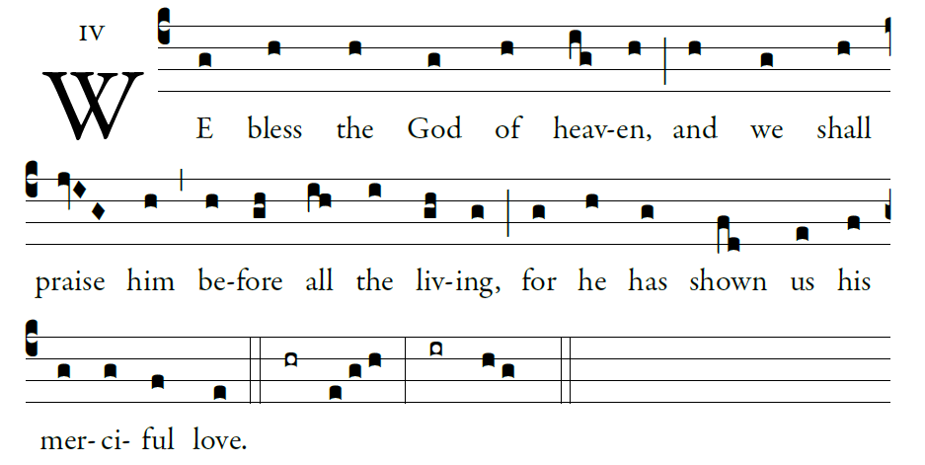
©Illuminarepublication.com

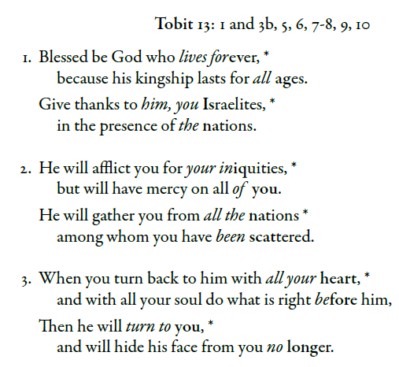

RECESSIONAL HYMN

“ Holy God We Praise thy Name”

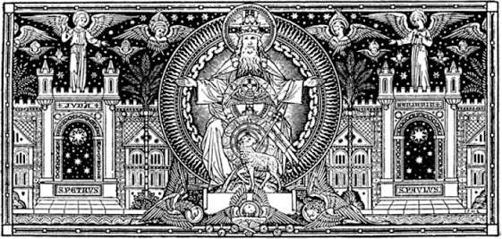
The Solemnity of the Most Holy Trinity

YEAR A
ENTRANCE ANTIPHON
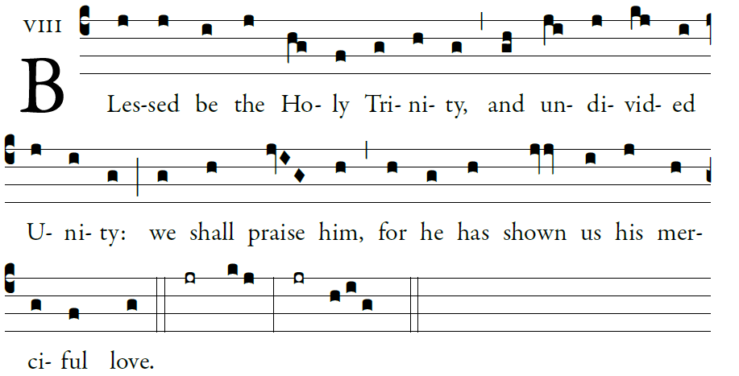
Illuminarepublications.com
O LORD, our Lord, how majestic
is your name through all the earth!
Your majesty is set above the heavens.

³From the mouths of children and of babes
you fashioned praise to foil your enemy,
to silence the foe and the rebel. 

Glory be…

KYRIE #839 GLORIA #840 Music Issue

RESPONSORIAL PSALM DN 3:52, 53, 54, 55, 56

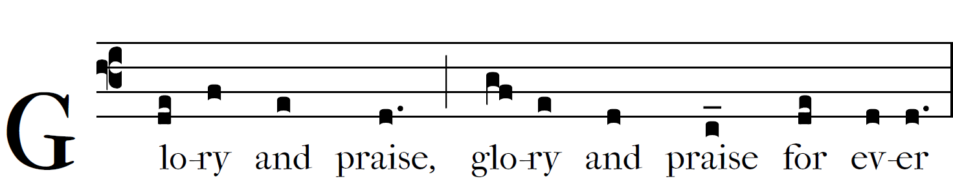

 Glory and praise for ever!

Blessed are you, O Lord, the God of our fathers,
praiseworthy and exalted above all forever;
And blessed is your holy and glorious name,
praiseworthy and exalted above all for all ages.

  Glory and praise for ever!
Blessed are you in the temple of your holy glory,
praiseworthy and glorious above all forever.

  Glory and praise for ever!
Blessed are you on the throne of your kingdom,
praiseworthy and exalted above all forever.

 Glory and praise for ever!
Blessed are you who look into the depths
from your throne upon the cherubim,
praiseworthy and exalted above all forever.

 Glory and praise for ever!

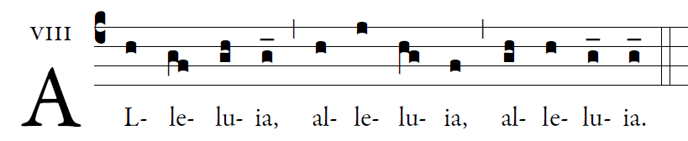
Illuminarepublications.com

Glory to the Father, the Son, and the Holy Spirit;
to God who is, who was, and who is to come.

OFFERTORY HYMN “Dwelling Place”

SANCTUS #841 Music Issue Mass XVIII Jubilate Deo

AGNUS DEI Mass of the Angels
