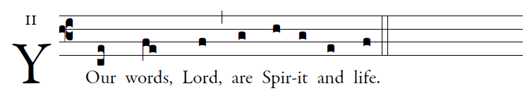
illuminarepublications.com

The law of the LORD is perfect,
refreshing the soul;
The decree of the LORD is trustworthy,
giving wisdom to the simple. 
The precepts of the LORD are right,
rejoicing the heart;
The command of the LORD is clear,
enlightening the eye. 
The fear of the LORD is pure,
enduring forever;
The ordinances of the LORD are true,
all of them just. 
Let the words of my mouth and the thought of my heart
find favor before you,
O LORD, my rock and my redeemer. 
