Why, what hath my Lord done?
What makes this rage and spite?
He made the lame to run,
He gave the blind their sight,
Sweet injuries! Yet they at these
Themselves displease, and ’gainst Him rise.
They rise and needs will have
My dear Lord made away;
A murderer they saved,
The Prince of life they slay,
Yet cheerful He to suffering goes,
That He His foes from thence might free.
In life, no house, no home
My Lord on earth might have;
In death no friendly tomb
But what a stranger gave.
What may I say? Heav’n was His home;
But mine the tomb wherein He lay.

Here might I stay and sing,
No story so divine;
Never was love, dear King!
Never was grief like Thine.
This is my Friend, in Whose sweet praise
I all my days could gladly spend.

+ + +

RECESSIONAL HYMN: “Jesus Remember Me” MI

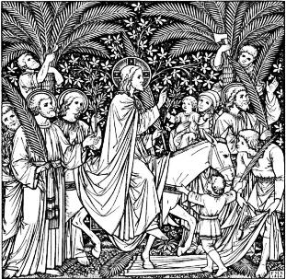

While the priest ,accompanied by
other ministers,
approach the place
where the people gathered,
the following antiphon is sung.

PALM SUNDAY

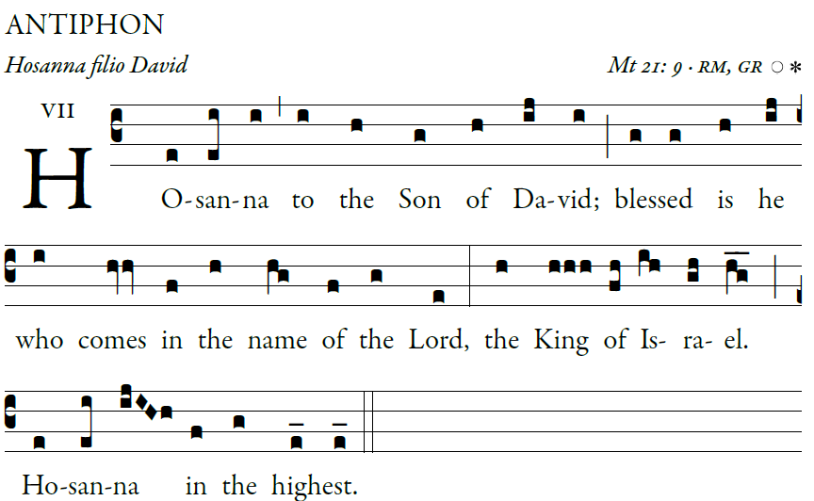

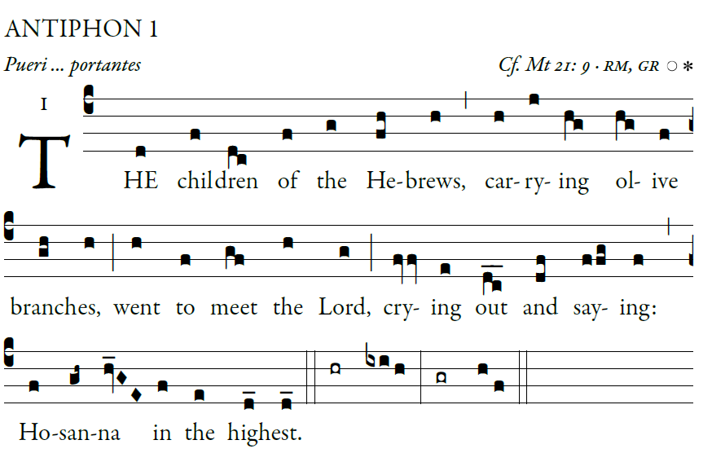
After the Palms are blest: As the procession moves forward, the following is sung by the choir and the people Mt 21:9

RESPONSORIAL PSALM

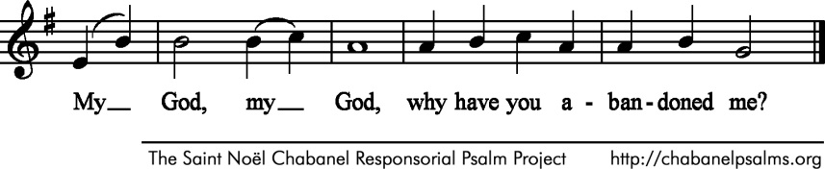
Ps 22:8-9, 17-18, 19-20, 23-24
All who see me scoff at me;
they mock me with parted lips, they wag their heads:
“He relied on the LORD; let him deliver him,
let him rescue him, if he loves him.” 
Indeed, many dogs surround me,
a pack of evildoers closes in upon me;
They have pierced my hands and my feet;
I can count all my bones. 
They divide my garments among them,
and for my vesture they cast lots.
But you, O LORD, be not far from me;
O my help, hasten to aid me. 
I will proclaim your name to my brethren;
in the midst of the assembly I will praise you:
“You who fear the LORD, praise him;
all you descendants of Jacob, give glory to him;
revere him, all you descendants of Israel!” 

VERSE BEFORE THE GOSPEL

2017 English propers © illuminarepublication.com

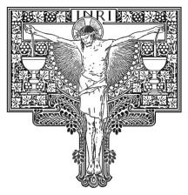
OFFERTORY HYMN “O Sacred Head”

Sanctus
Agnus Dei

COMMUNION ANTIPHON

Father, if this cup cannot pass away
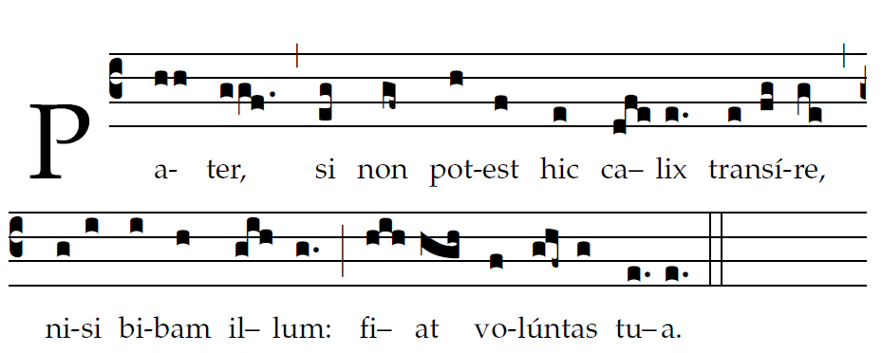
unless your will be done, thy will be done/

COMMUNION HYMN “My Song is Love Unknown” Samuel Crossman, 1664
My song is love unknown,
My Savior’s love to me;
Love to the loveless shown,
That they might lovely be.
O who am I, that for my sake
My Lord should take,
frail flesh and die.

2. He came from his blest throne
Salvation to bestow;
But some my scorn, and none
The longed-for Christ would know:
But O! my Friend, my Friend indeed,
Who at my need
His life did spend.

3. Sometimes they strew His way,
And His sweet praises sing;
Resounding all the way
Hosannas to their King:
Then “Crucify!” is all their breath,
And for His death they thirst and cry.

