COMMUNION ANTIPHON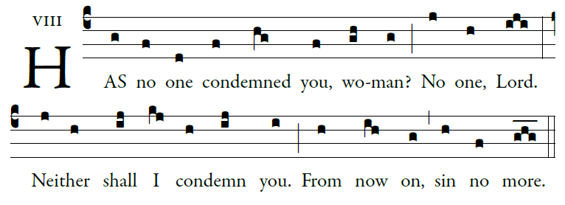
©illuminarepublications Adam Bartlett
Psalm 32
Blessed is he whose transgression is forgiven
whose sin is remitted.
²Blessed the man to whom the LORD imputes no guilt,
in whose spirit is no guile.

³I kept it secret and my frame was wasted.
I groaned all day long,

³To you I have acknowledged my sin;
my guilt I did not hide.
I said, “I will confess my transgression to the LORD.”
And you have forgiven the guilt of my sin.

I will instruct you and teach you
the way you should go;
I will fix my eyes upon you.

Many sorrows has the wicked,
but loving mercy surrounds
one who trusts in the LORD.

Rejoice in the LORD; exult, you just!
Ring out your joy, all you upright of heart.

RECESSIONAL HYMN
“All Is Well with My Soul”

FIFTH SUNDAY OF LENT

ENTRANCE ANTIPHON

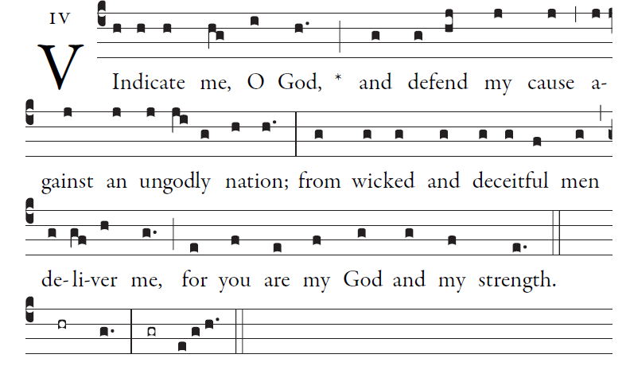 ©CMAA SIMPLE ENGLISH PROPERS

O send forth your light and your truth;
they will guide me on.
They will bring me to your holy mountain,
to the place where you dwell.
And I will come to the altar of God,
to God, my joy and gladness.
To you will I give thanks on the harp,
O God, my God.
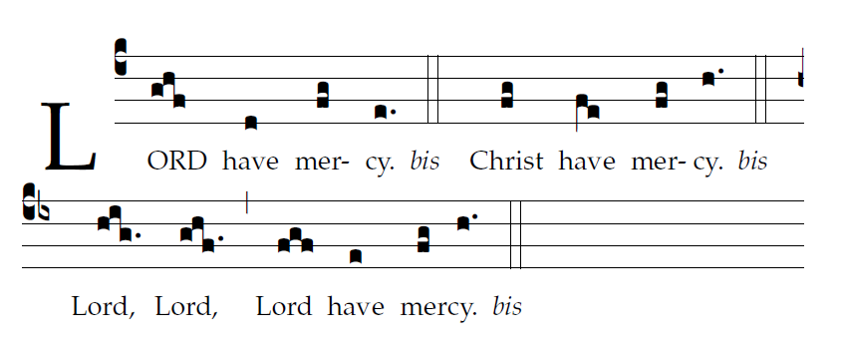
Mass in honor of Pope St. John Paul II Richard J. Clark used with permission

OFFERTORY HYMN

MISERICORDIAS Music 2007, Henryk Jan Botar
permission pending
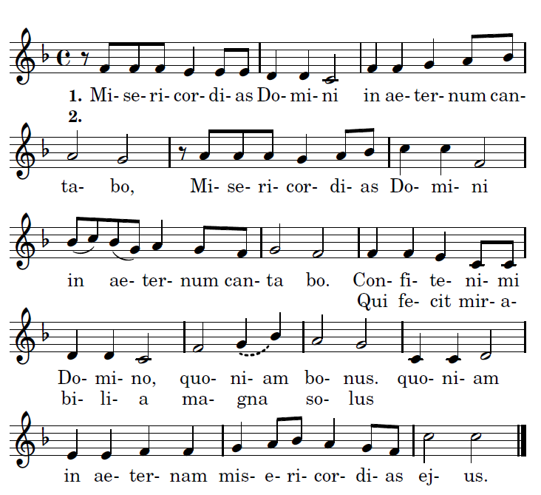

Refrain:
I will sing of the mercies of the Lord forever.

1. Praise the Lord, for he is good: for his mercy endures forever.
2. Who alone does great wonders: for his mercy endues forever.

HOLY
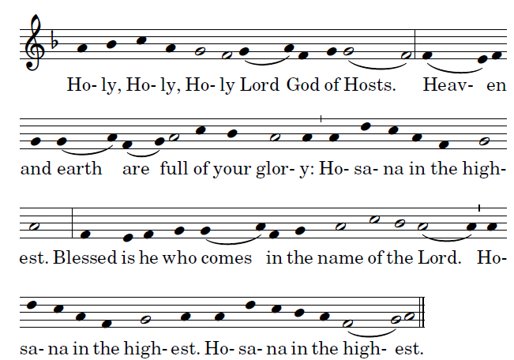

ACCLAMATION
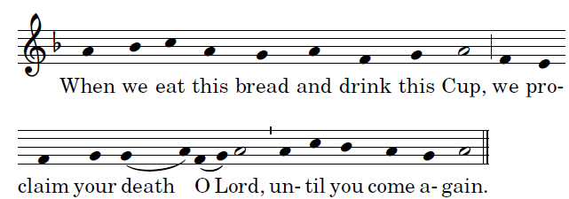

AGNUS DEI
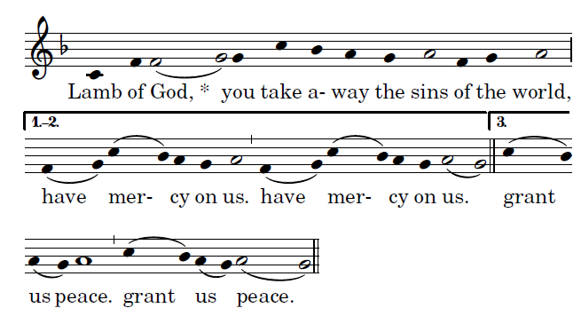
, Mass in honor of Pope St. John Paul II Richard J. Clark used with permission

