LAMB OF GOD
Music copyright © 2014 Richard J. Clark | rjcceciliamusic.com

COMMUNION ANTIPHON:

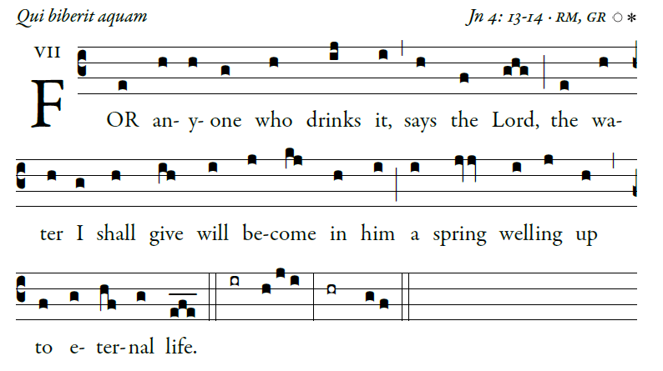

illuminare publications Adam Bartlett

RECESSIONAL HYMN
“ All is Well with My Soul”
Music Issue Numbers posted

THIRD SUNDAY OF LENT (year A)

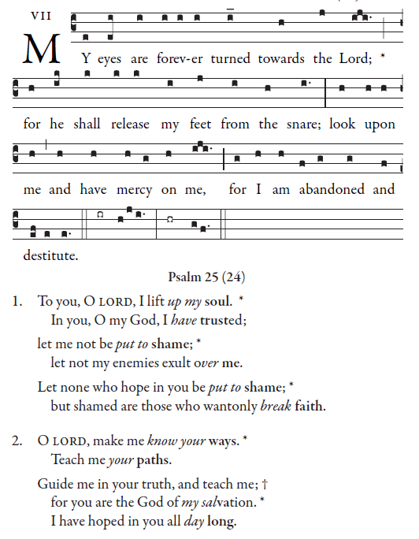
Music copyright © 2014 Richard J. Clark | rjcceciliamusic.com

Simple English Propers Adam Bartlett © CMMA

RESPONSORIAL PSALM
R. Bednarz 2014
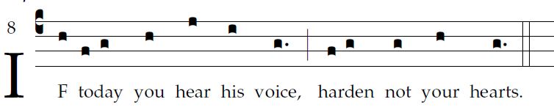

Come, let us sing joyfully to the LORD;
let us acclaim the rock of our salvation.
Let us come into his presence with thanksgiving;
let us joyfully sing psalms to him.
Come, let us bow down in worship;
let us kneel before the LORD who made us.
For he is our God,
and we are the people he shepherds, the flock he guides.

Oh, that today you would hear his voice: [5]
"Harden not your hearts as at Meribah,
as in the day of Massah in the desert,
Where your fathers tempted me;
Though they had seen my work.

VERSE BEFORE THE GOSPEL

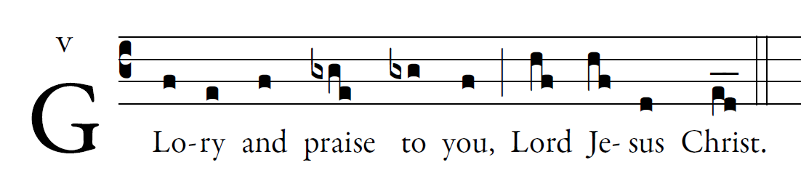

OFFERTORY ANTIPHON
Lord, turn to me, hope for my soul. Save me according to your mercy.
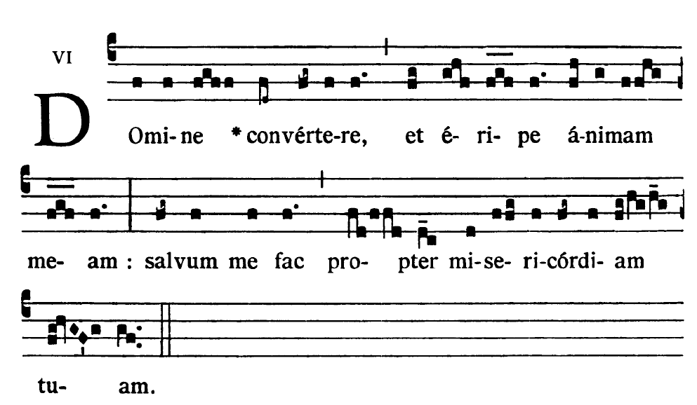
HOLY
Music copyright © 2014 Richard J. Clark | rjcceciliamusic.com
ACCLAMATION
