COMMUNION ANTIPHON:
Based on Fr. Columbo Kelly’s Communion Proper s congregation’s refrain
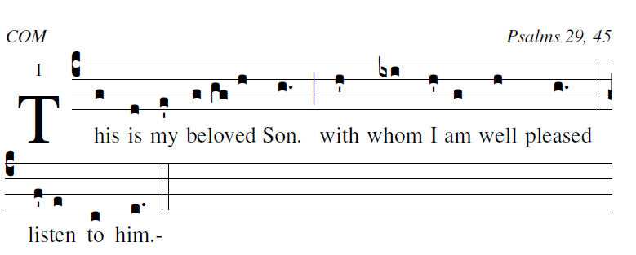Psalm 19
Ascribe to the LORD, you heavenly powers,
ascribe to the LORD glory and strength.
Ascribe to the LORD the glory of his name;
bow down before the LORD, majestic in holiness.

The voice of the LORD upon the waters,
the God of glory thunders;
the LORD on the immensity of waters;
the voice of the LORD full of power;
the voice of the LORD full of splendor.

The voice of the LORD shatters cedars,
the LORD shatters the cedars of Lebanon;
he makes Lebanon leap like a calf,
and Sirion like a young wild-ox.

The voice of the LORD flashes flames of fire.
The voice of the LORD shakes the wilderness,
the LORD shakes the wilderness of Kadesh;
The voice of the LORD rends the oak tree
and strips the forest bare.

RECESSIONAL HYMN:
“At the Name of Jesus

SECOND SUNDAY OF LENT

ENTRANCE ANTIPHON

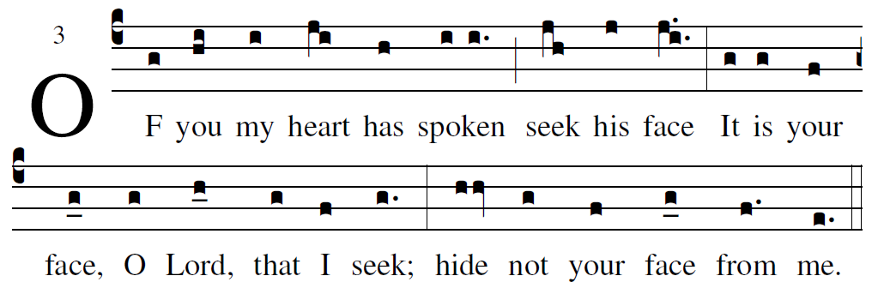
Based on the Simple English Propers by Adam Bartlett,
revised with the Text for the Missal text.by RB

The LORD is my light and my salvation;
whom shall I fear?
The LORD is the stronghold of my life;
whom should I dread?

When those who do evil draw near
to devour my flesh,
it is they, my enemies and foes,
who stumble and fall.

For there he keeps me safe in his shelter
in the day of evil.
He hides me under cover of his tent;
he sets me high upon a rock.

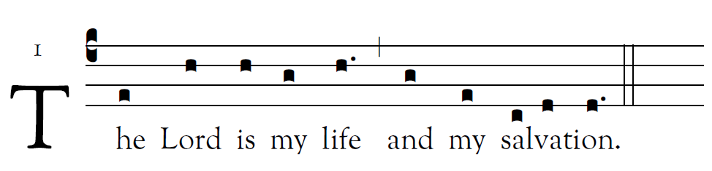
The LORD is my light and my salvation;
whom should I fear?
The LORD is my life’s refuge;
of whom should I be afraid? 
Hear, O LORD, the sound of my call;
have pity on me, and answer me.
Of you my heart speaks;
you my glance seeks.    
Your presence, O LORD, I seek.
Hide not your face from me;
do not in anger repel your servant.
You are my helper: cast me not off.    
I believe that I shall see the bounty of the LORD
in the land of the living.
Wait for the LORD with courage;
be stouthearted, and wait for the LORD. 

VERSE BEFORE THE GOSPEL
Adam Bartlett IlluminarePublications.com
From the shining cloud the Father’s voice was heard:
This is my beloved Son, listen to him. 

OFFERTORY HYMN:
“Humbly Lord We Worship You ”

SANCTUS Music copyright © 2014 Richard J. Clark | rjcceciliamusic.com
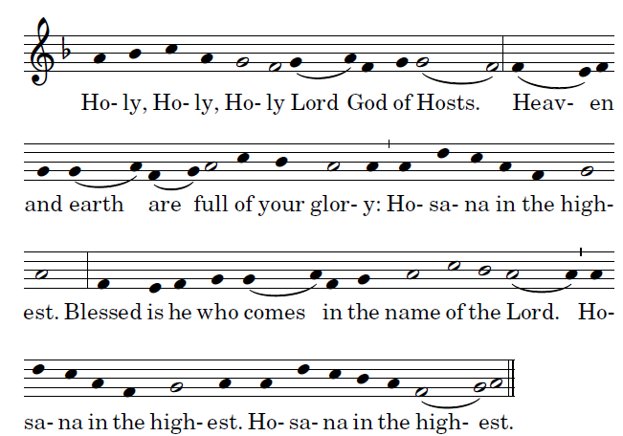
MEMORIAL ACCLAMATION
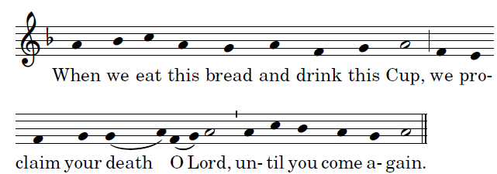
LAMB OF GOD
