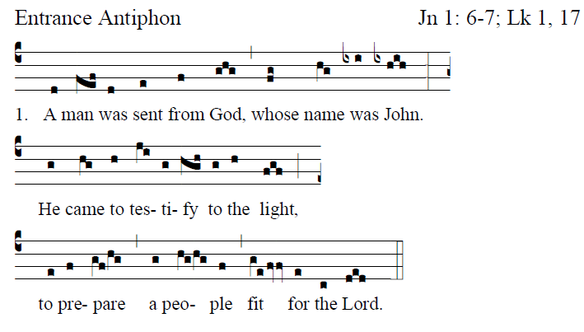

Fr.Columba Kelley @Saint Meinrad Archabbey

It is good to give thanks to the LORD,
to make music to your name, O Most High,
to proclaim your loving mercy in the morning,
and your truth in the watches of the night,

You have gladdened me, O LORD, by your deeds;
How deep are your designs!
The senseless cannot know this,
and the fool cannot understand.

The just man shall flourish like the palm tree,
like a cedar of Lebanon shall he grow.
They that are planted in the house of the Lord
shall flourish in the courts of our God.
