OFFERTORY HYMN
_
_
_
_
_

Holy Holy Holy,, Acclamation, Amen, and Lamb of God
Missa Simplex booklet

COMMUNION CHANT

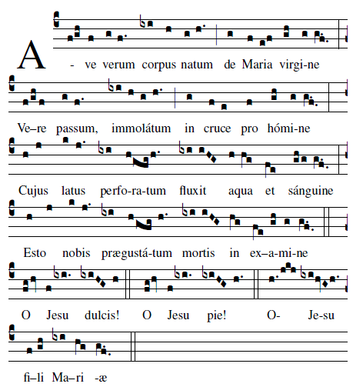

Hail, true body born of the Virgin Mary, Who truly suffered, sacrificed on the Cross for man, Whose pierced side overflowed with water and blood , Be for us a foretaste in the test of death. O sweet Jesus! O Loving Jesus! O Jesus Son of Mary.

CHOIR Nos autem gloriari oportet in Cruce Domini nostri Iesu Christi: in quo est salus, vita, et resurrectio nostra: per quem salus, vita, et resurrectio nostra: per quem salvati, et liberati sumus.

We have no other glory but the cross of Our Lord Jesus Christ: in Whom is our salvation, life, and resurrection; by whom we are saved and de

PROCESSION kneel

“Sing, My Tongue,the Savior’s Glory”
page 21 Today’s Missal

After the procession the following Hymn is sung
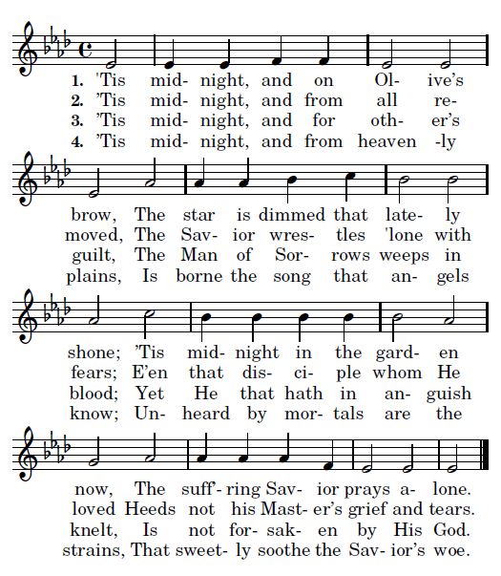

2017
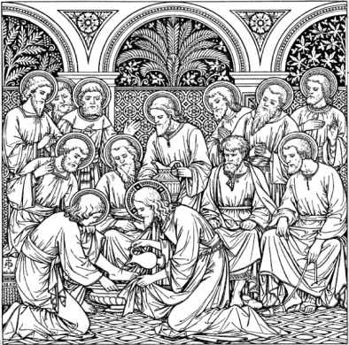
HOLY THURSDAY

We have no glory
but in the cross
of our Lord Jesus Christ.
In Him we have salvation,
life, and resurrection:
through Him we are rescued
and set free.

ENTRANCE HYMN “My Song is Love Unknown”
Samuel Crossman 1664

My song is love unknown,
My Savior’s love to me;
Love to the loveless shown,
That they might lovely be.
O who am I, that for my sake
My Lord should take,
frail flesh and die.

2. He came from his blest throne
Salvation to bestow;
But some my scorn, and none
The longed-for Christ would know:
But O! my Friend, my Friend indeed,
Who at my need
His life did spend.

4. Here might I stay and sing,
No story so divine;
Never was love, dear King!
Never was grief like Thine.
This is my Friend, in Whose sweet praise
I all my days could gladly spend.

3. They rise and needs will have
My dear Lord made away;
A murderer they saved,
The Prince of life they slay,
Yet cheerful He to suffering goes,
That He His foes
from thence might free.

KYRIE AND GLORIA Missa Simplex Booklet

LITRURGY OF THE WORD page 16 TM

THE WASHING OF FEET: #613 MI “ I Have Loved You
with an Everlasting Love”
#505 we Have Been Told

