OFFERTORY 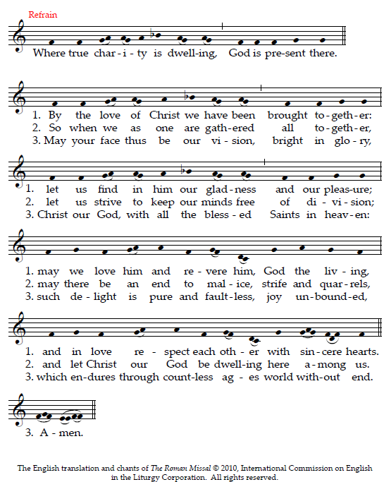

CHOIR Nos autem gloriari oportet in Cruce Domini nostri Iesu Christi: in quo est salus, vita, et resurrectio nostra: per quem salus, vita, et resurrectio nostra: per quem salvati, et liberati sumus.

But it behooves us to glory in the cross of Our Lord Jesus Christ: in Whom is our salvation, life, and resurrection; by whom we are saved and delivered.

COMMUNION CHANT

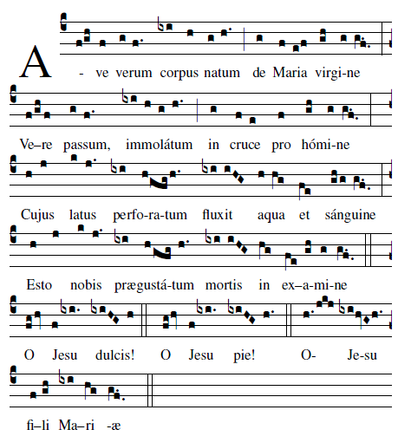

Hail, true body born of the Virgin Mary, Who truly suffered, sacrificed on the Cross for man, Whose pierced side overflowed with water and blood , Be for us a foretaste in the test of death. O sweet Jesus! O Loving Jesus! O Jesus Son of Mary.

COMMUNION HYMN : “O Saving Victim”
inside the back cover of the Today’s Missal

PROCESSION ALL KNEEL

“Pange Lingua” page 18 Today’s Missal
“Tantum Ergo” When the procession arrives
at the altar of repose

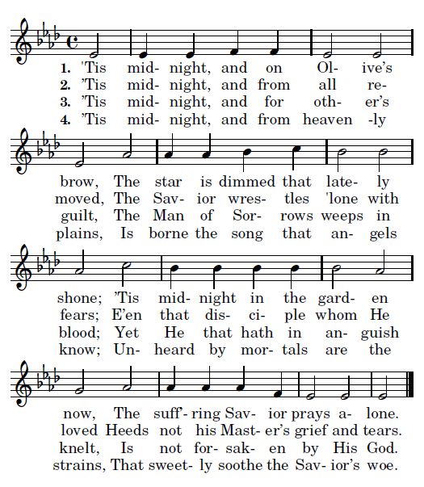

St. John Nepomucene

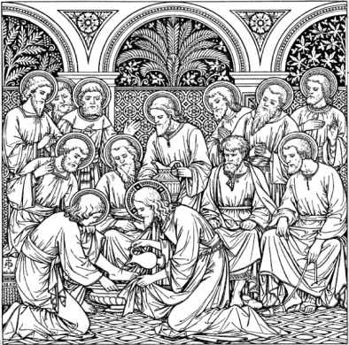
HOLY THURSDAY

ENTRANCE HYMN

Jesus, my Lord, my God, my all!
How can I love Thee as I ought?
And how revere this wondrous gift,
So far surpassing hope or thought?

Refrain:
Sweet Sacrament, we Thee adore!
Oh, make us love Thee more and more.
Oh, make us love Thee more and more.

2. Had I but Mary's sinless heart
With which to love Thee, dearest King,
Oh, with what ever fervent praise,
Thy goodness, Jesus, would I sing!
Refrain

3. Thy Body, Soul and Godhead, all!
O mystery of love divine!
I cannot compass all I have,
For all Thou hast and art is mine!

4. Sound, then, His praises higher still,
And come, ye angels, to our aid;
For this is God, the very God
Who hath both men and angels made!

KYRIE AND GLORIA Missa Simplex Booklet

LITRURGY OF THE WORD page 14 TM

THE WASHING OF FEET: song “ We Have Been Told”

