PROCESSIONAL HYMN

STABAT MATER

A
t the Cross her station keeping,
Stood a mournful Mother weeping,
Close to Jesus to the last.

Stunned and stricken, Mary, Mother,
In your arms was placed our Brother,
"Full of grace" now filled with grief.

Is there one who would not weep,
'Whelmed in miseries so deep
Christ's dear Mother to behold?

Let me share with you His pain,
Who for all our sins was slain,
Who for me in torments died.

Pierced the hands that blessed and cured us;
Pierced the feet that walked to free us,
Walked the hill of Calvary.

Life eternal, death defiant,
Bowed his head the world was silent,
Through his death came life anew.

2017
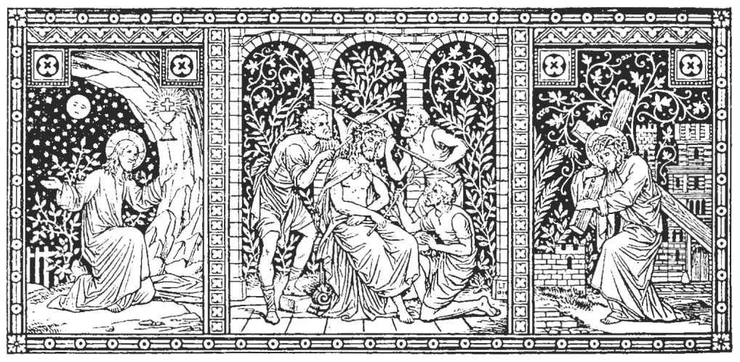
FRIDAY OF THE LORD’S PASSION

Page 23 Today’s Missal

ADORATION OF THE CROSS R. Bednarz 2016

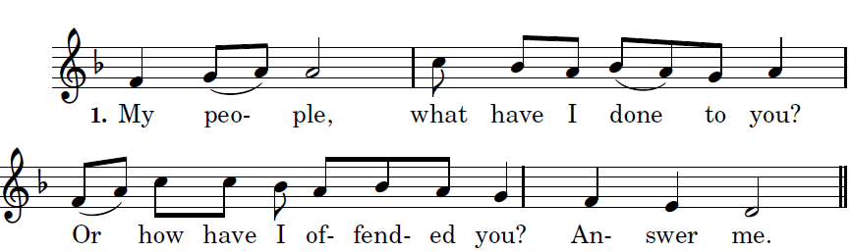

 Because I led you out of the land of Egypt,
you have prepared a Cross for your Savior

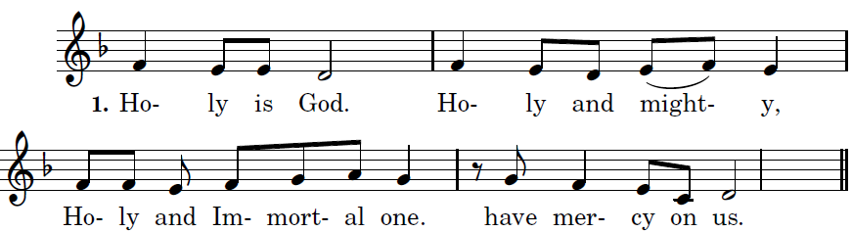

 Because I led you out through the desert
for forty years and fed you with manna
and brought you into a land of plenty,
you have prepared a cross for your Savior.

   Holy is God

 What more should I have done for you
and have not done?
Indeed, I planted you as my most beautiful chosen vine
and you have turned very bitter for me,
or in my thirst you gave me vinegar to drink
and with a lance you pierced your Savior’s side.

 Holy is God

 I scourged Egypt for your sake with its firstborn sons,
and you scourged me and handed me over.
I led you out from Egypt/ as Pharoah
lay sunk in the Red Sea,
and you handed me over to the chief priests

 My people. . .

 I opened up the sea before you,
and you opened my side with a lance.
I went before you in a pillar of cloud,
and you led me into Pilate’s palace.

 My people. . .

           I fed you with manna in the desert,
and on me you rained blows and lashes.
I gave you saving water from the rock to drink,
and for drink you gave me gall and vinegar.

           My people. .

 I struck down for you the kings of the Canaanites,
and you struck my head with a reed.
I put in your hand a royal scepter,
and you put on my head a crown of thorns.

 My people. . .
  Holy is God

PREPARATION OF THE ALTAR for COMMUNION
As the reserved Eucharist is brought into the church

Hail, true body born of the Virgin Mary, Who truly suffered, sacrificed on the Cross for man, Whose pierced side overflowed with water and blood , Be for us a foretaste in the test of death. O sweet Jesus! O Loving Jesus! O Jesus Son of Mary.

