RECESSIONAL HYMN:



SIXTH SUNDAY OF EASTER c

ENTRNACE ANTIPHON

Fr. Columba Kelley

Saint Meinrad Archabbey© 2010

Creative Commons Attribution-Noncommercial-No Derivative Works 3.0 United States License.

OFFERTORY HYMN “ Come Holy Ghost””

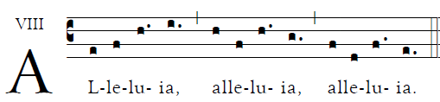

******

COMMUNNION ANTIPHON

Fr. Columba Kelley