LAMB OF GOD

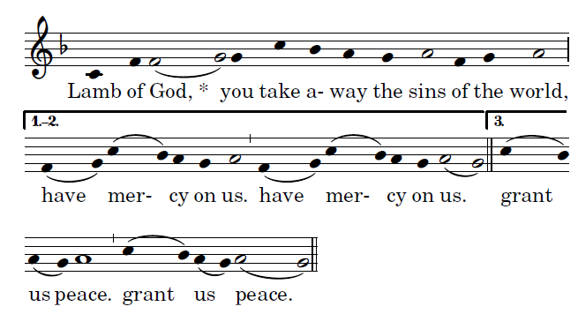

COMMUNION ANTIPHON yeaRSab &C

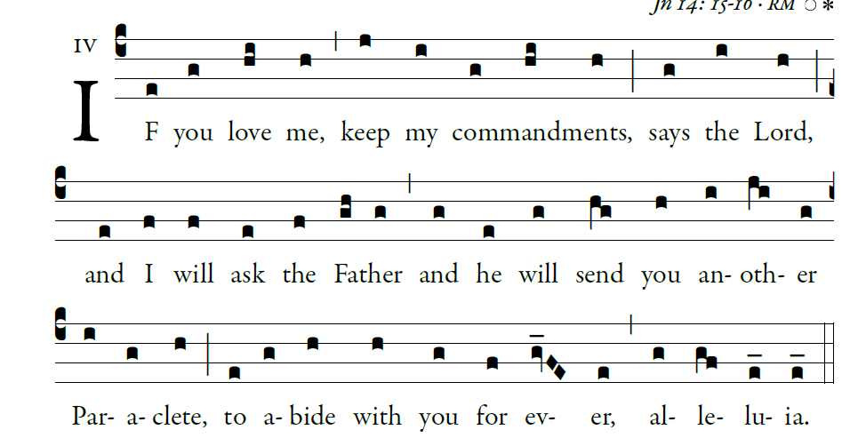
Illuminarepublications.com

RECESSIONAL HYMN: “Hail Holy Queen”

Sixth Sunday of Easter _{YEAR B}

ENTRANCE ANTIPHON ANTIPHON

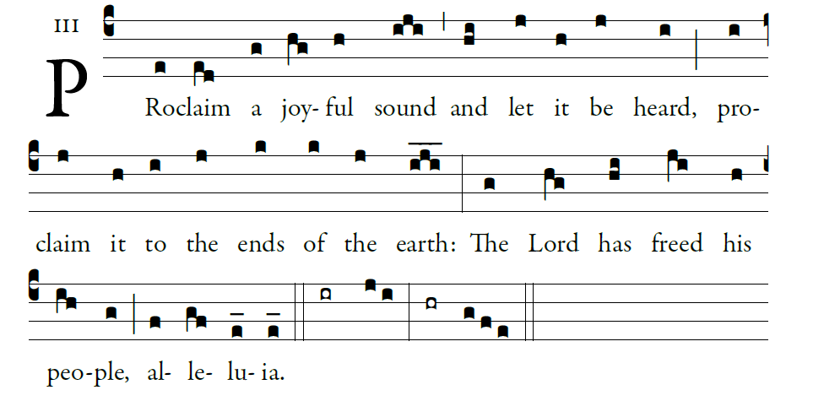

PROPERS FROM ILLUMINAREPUBLICATIONS.COM
GLORIA
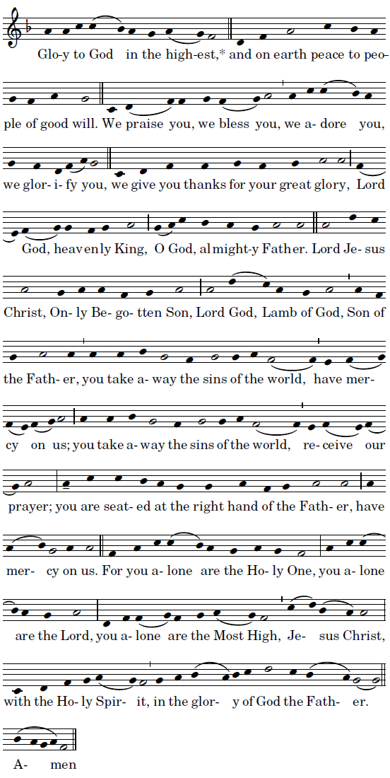

Mass ordinaries ©Richard Clark reprinted with permission

RESPONSORIAL PSALM

Sing to the LORD a new song,
for he has done wondrous deeds;
His right hand has won victory for him,
his holy arm.
The LORD has made his salvation known:
in the sight of the nations he has revealed his justice.
He has remembered his kindness and his faithfulness
toward the house of Israel.

All the ends of the earth have seen
the salvation by our God.
Sing joyfully to the LORD, all you lands;
break into song; sing praise

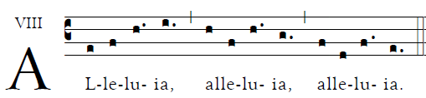

OFFERTORY HYMN “ Veni Sante Spiritus “

HOLY
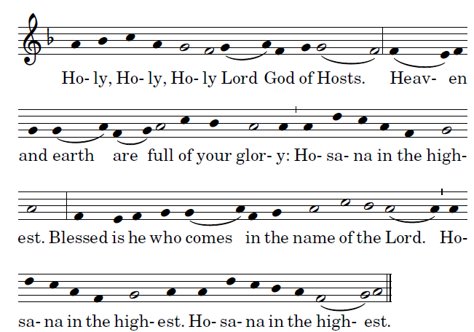

ACCLAMATION
