COMMUNION ANTIPHON

O shepherd of Israel, hear us,
you who lead Joseph like a flock:
you drove out the nations and planted it.
¹Before it you cleared the ground;
it took root and filled the land.

The mountains were covered with its shadow,
the cedars of God with its boughs.
It stretched out its branches to the sea;
to the River it stretched out its shoots.

RECESSIONAL HYMN:
“ Hail Holy Queen ”

English proper Antiphons from Illuminare Publications.

Fifth Sunday of Easter YEAR C

ENTRANCE ANTIPHON

O sing a new song to the LORD,
for he has worked wonders.
His right hand and his holy arm
have brought salvation.

²The LORD has made known his salvation,
has shown his deliverance to the nations.
³He has remembered his merciful love
and his truth for the house of Israel.

Kyrie and Glory to God Today’s Missa English Chant

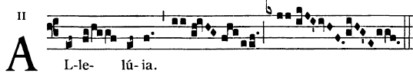

OFFERTROY ANTIPHON (choir)
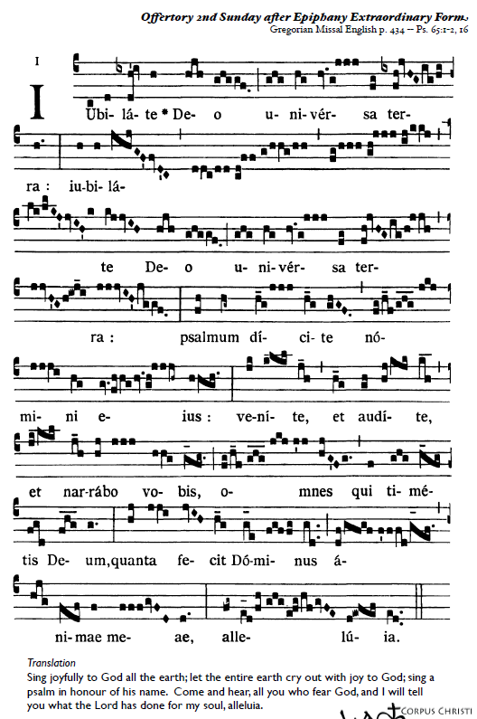

LAMB OF GOD

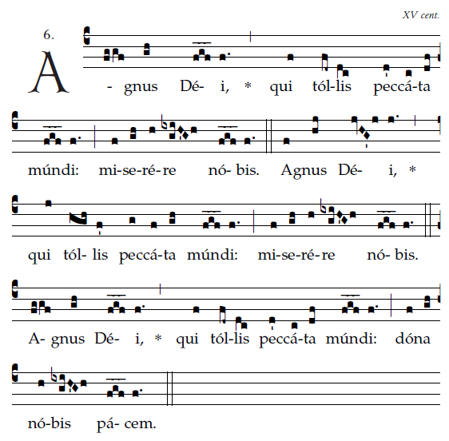

COMMUNION HYMN
“Draw Near” 486
in the GLORY AND PRAISE Hymnal

