Communion Antiphon

²O shepherd of Israel, hear us,
you who lead Joseph like a flock:
you drove out the nations and planted it.
¹⁰Before it you cleared the ground;
it took root and filled the land.

¹¹The mountains were covered with its shadow,
the cedars of God with its boughs.
¹²It stretched out its branches to the sea;
to the River it stretched out its shoots.

Visit this vine and protect it,
¹⁶the vine your right hand has planted,
the son of man you have claimed for yourself.
¹⁸May your hand be on the man at your right hand,
the son of man you have confirmed as your own.

¹⁹And we shall never forsake you again;
give us life that we may call upon your name.

Recessional Hymn:
“ Regina Caeli” #70 TM

Fifth Sunday of Easter

Entrance Antiphon

O sing a new song to the LORD,
for he has worked wonders.
His right hand and his holy arm
have brought salvation.

²The LORD has made known his salvation,
has shown his deliverance to the nations.
³He has remembered his merciful love
and his truth for the house of Israel.
All the ends of the earth have seen
the salvation of our God.
⁴Shout to the LORD, all the earth;
⁵ break forth into joyous song,
and singout your praise.

Kyrie and Glory to God page 74 in today’s Missal

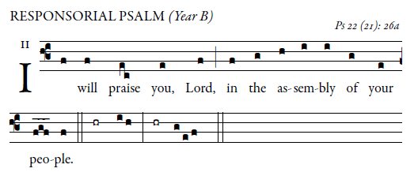

I will fulfill my vows before those who fear the LORD.
The lowly shall eat their fill;
they who seek the LORD shall praise him:
“May your hearts live forever!” 
All the ends of the earth
shall remember and turn to the LORD;
all the families of the nations
shall bow down before him.  
To him alone shall bow down
all who sleep in the earth;
before him shall bend
all who go down into the dust. 
And to him my soul shall live;
my descendants shall serve him.
Let the coming generation be told of the LORD
that they may proclaim to a people yet to be born
the justice he has shown. 

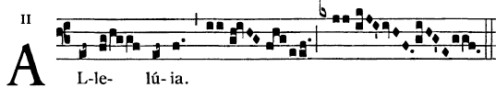

     Remain in me as I remain in you, says the Lord.
Whoever remains in me will bear much fruit.

Offertroy Hymn
“We Have Been Told” #505 MI
Holy #26 page 113 TM

Acclamation #26 page 115 TM

Lamb of God

