Visit this vine and protect it,
the vine your right hand has planted,
the son of man you have claimed for yourself.
May your hand be on the man at your right hand,
the son of man you have confirmed as your own.

And we shall never forsake you again;
give us life that we may call upon your name.

RECESSIONAL HYMN

FATIMA AVE
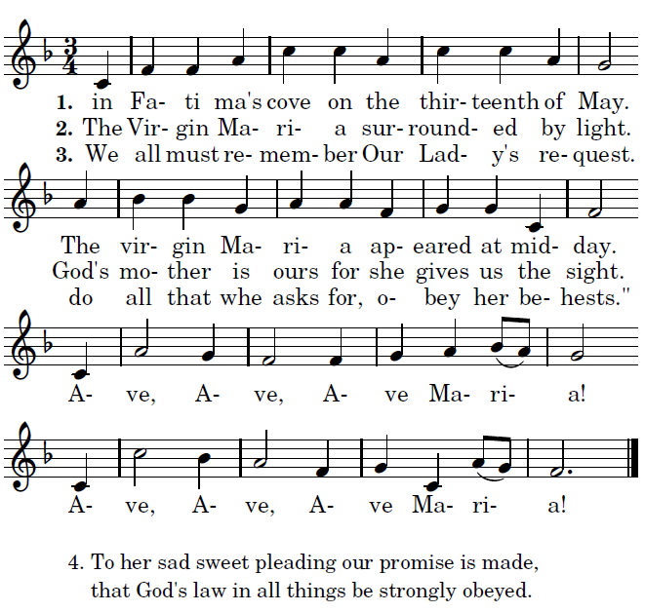

Propers from © www.illuminarepublications.com
“Glory to God” Fr. Columba Kelley ©Saint Meinrad Archabbey

Fifth Sunday of Easter

Entrance Antiphon

O sing a new song to the LORD,
for he has worked wonders.
His right hand and his holy arm
have brought salvation.

The LORD has made known his salvation,
has shown his deliverance to the nations.
He has remembered his merciful love
and his truth for the house of Israel.

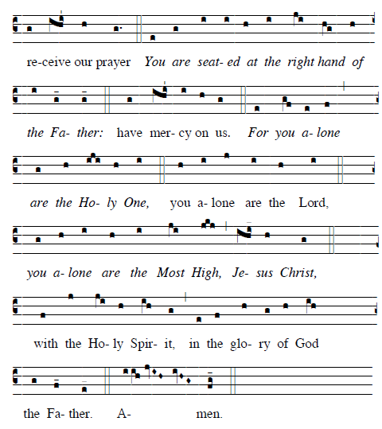

Offertory Hymn “ Regina Caeli”

Communion Antiphon

O shepherd of Israel, hear us,
you who lead Joseph like a flock:
you drove out the nations and planted it.
Before it you cleared the ground;
it took root and filled the land.

The mountains were covered with its shadow,
the cedars of God with its boughs.
It stretched out its branches to the sea;
to the River it stretched out its shoots.
continued

