Offertory Hymn “Ubi Caritas” 702
Holy,
Amen
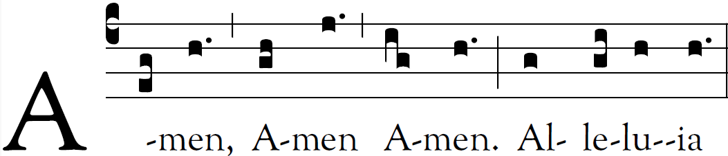

Communion Antiphon:

Psalm 23
The LORD is my shepherd;
there is nothing I shall want.
Fresh and green are the pastures
where he gives me repose.
Near restful waters he leads me;
he revives my soul.

Recessional Hymn: “Regina Cæli” 525

Fourth Sunday of Easter

Entrance Antiphon

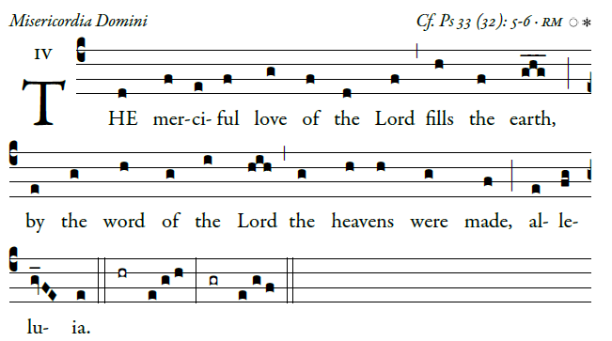
©Illuminare Publications.com
Ring out your joy to the lord, O you just;
for praise is fting for the upright
Give thanks to the lord upon the harp;
with a ten-stringed lute sing him songs. 
O sing him a song that is new;
play skillfully, with shouts of joy.
For the word of the lord is faithful,
and all his works to be trusted.
Let all the earth fear the orLd,
all who live in the world revere him. 

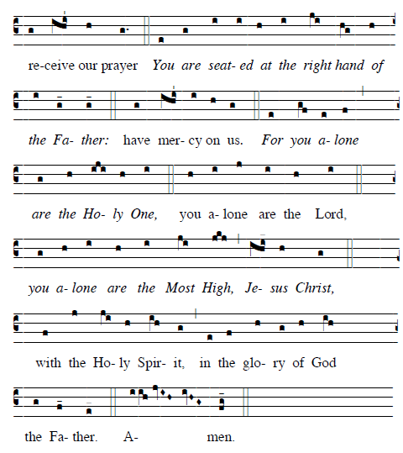

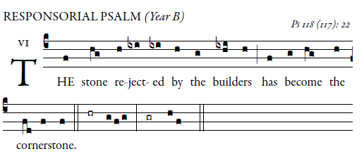

Give thanks to the LORD, for he is good,
for his mercy endures forever.
It is better to take refuge in the LORD
than to trust in man.
It is better to take refuge in the LORD
than to trust in princes.  
I will give thanks to you, for you have answered me
and have been my savior.
The stone which the builders rejected
has become the cornerstone.
By the LORD has this been done;
it is wonderful in our eyes.  
Blessed is he who comes in the name of the LORD;
we bless you from the house of the LORD.
I will give thanks to you, for you have answered me
and have been my savior.
Give thanks to the LORD, for he is good;
for his kindness endures forever.  
