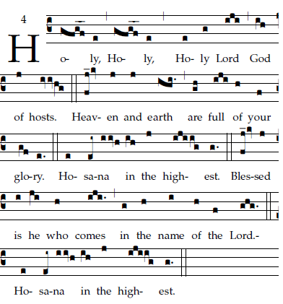

Repeat
Final ending

COMMUNION HYMN: “Gift of Finest Wheat”

RECESSIONAL HYMN: “Be Joyful Mary”

FOURTH SUNDAY of EASTER

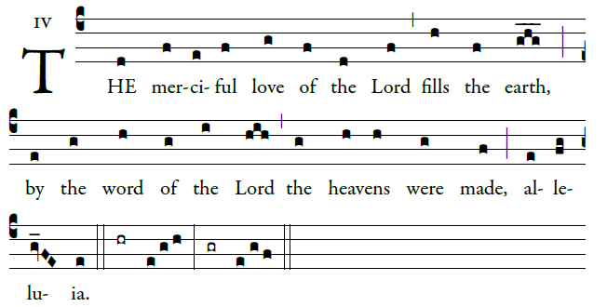
ENTRANCE ANTIPHON

Ring out your joy to the lord, O you just;
for praise is fi tting for the upright
Give thanks to the Lord upon the harp;
with a ten-stringed lute sing him songs. 
O sing him a song that is new;
play skillfully, with shouts of joy.
For the word of the Lord is faithful,
and all his works to be trusted.
Let all the earth fear the Lord,
all who live in the world revere him. 
©Illuminare Publications.com

Ordinary of the Masa: Mass I Fr. Columba Kelley.©Saint Meinrad Archabbey

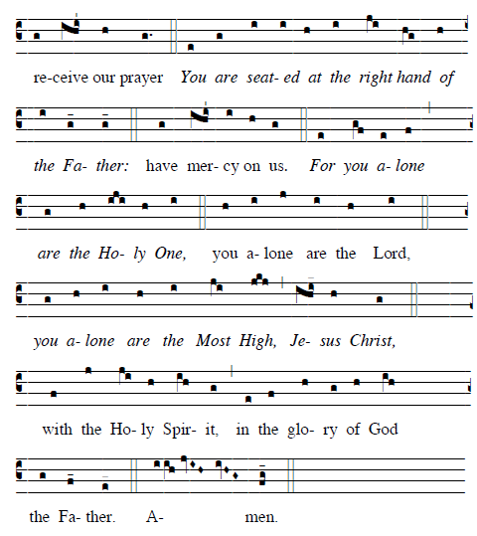

RESPONSORIAL PSALM
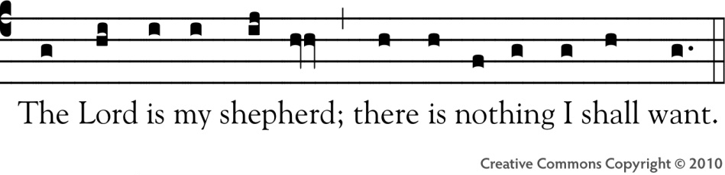

The LORD is my shepherd; I shall not want.
In verdant pastures he gives me repose;
beside restful waters he leads me;
he refreshes my soul.
He guides me in right paths
for his name's sake.
Even though I walk in the dark valley
I fear no evil; for you are at my side.
With your rod and your staff
that give me courage.
You spread the table before me
in the sight of my foes;
you anoint my head with oil;
my cup overflows.
Only goodness and kindness follow me
all the days of my life;
and I shall dwell in the house of the LORD
for years to come.

OFFERTROY HYMN: “Christ the Lord Is Risen Today”

