RESPONSORIAL PSALM

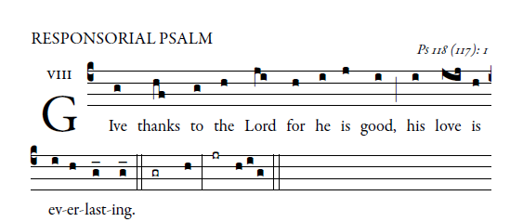
Let the house of Israel say,
“His mercy endures forever.”
Let the house of Aaron say,
“His mercy endures forever.”
Let those who fear the LORD say,
“His mercy endures forever.”\
I was hard pressed and was falling,
but the LORD helped me.
My strength and my courage is the LORD,
and he has been my savior.
The joyful shout of victory
in the tents of the just:
The stone which the builders rejected
has become the cornerstone.
By the LORD has this been done;
it is wonderful in our eyes.
This is the day the LORD has made;
let us be glad and rejoice in it.
ALLELUIA
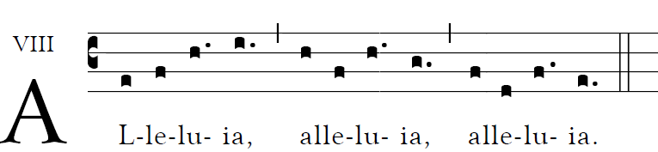

OFFERTORY HYMN

Hymn for the Holy Year of Mercy

Refrain 1 Be merciful as your Father is merciful.
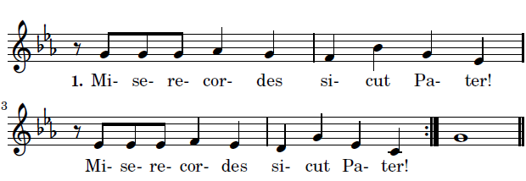

CANTOR: Give thanks to the Father, for hi is good:

ALL “ His mercy endures forever.”
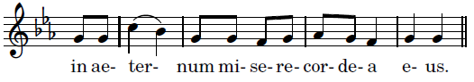

CANTOR: He created the world with wisdom
ALL In aeternum…

CANTOR: He leads his people thoughout history
ALL In aeternum…

CANTOR: He pardons and welcomes his childern
ALL In aeternum…

Refrain 1 Miserecordes sicut Pater.

© 2015 Pontifical Council for the Promotion of the New Evangelization. Authors of the original music Paul Inwood have donated the copyright.

COMMUNION ANTIPHON

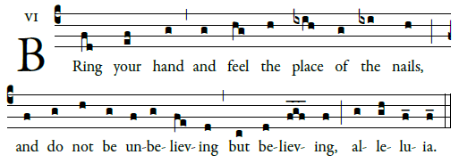

RECESSIONAL HYMN: Henryk Jan Botar
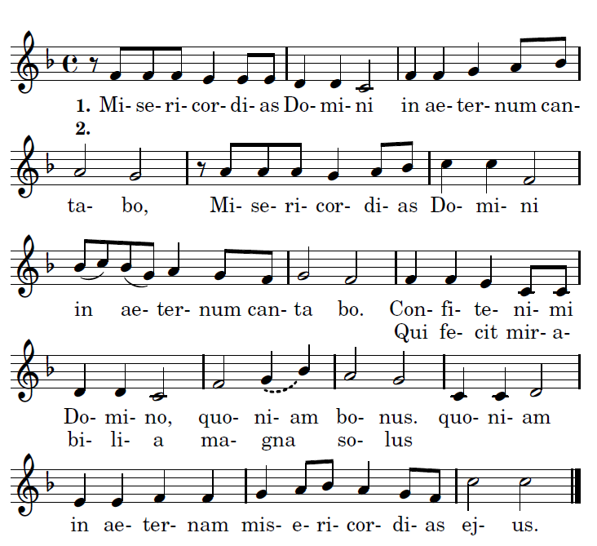

I will sing of the mercies of the lord forevere. Give thanks to the Lord for he is good, who alone has done marvelous deeds.

proper antiphons $©$ illluminarepublications.com

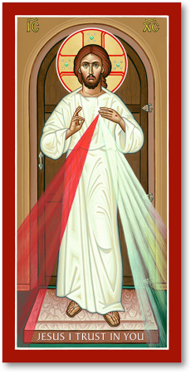

2nd SUNDAY of EASTER

DIVINE MERCY SUNDAY

ENTRANCE ANTIPHON

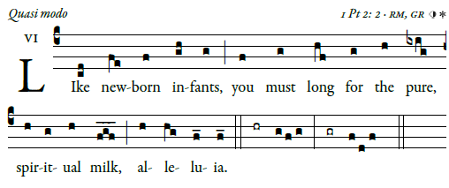
Sing joyfully to God our strength,
shout in triumph to the God of Jacob.
Raise a song and sound the timbrel,
the sweet-sounding harp and the lute;

blow the trumpet at the new moon,
when the moon is full, on our feast.
For this is a statute in Israel,
a command of the God of Jacob.

“I freed your shoulder from the burden;
You called in distress and I delivered you.

