COMMUNION ANTIPHON
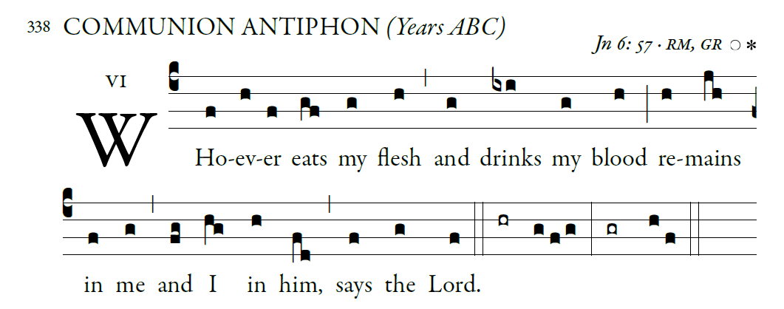
Fr. Columba Kelly. Saint Meinrad Archabbey

Blessed are those whose way is blameless,
who walk in the law of the LORD!
²Blessed are those who keep his decrees!
With all their hearts they seek him

I treasure your word in my heart,
lest I sin against you.
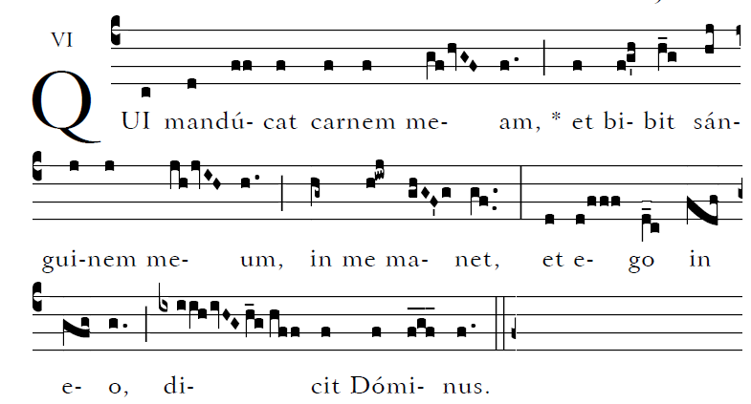

RECESSIONAL HYMN: “ SALVE REGINA”

(Hail, Holy Queen, Mother of Mercy)

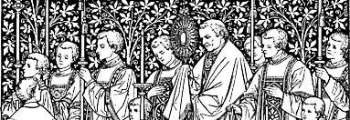
The Solemnity of the Most Holy Body and Blood of Christ

ENTRANCE ANTIPHON

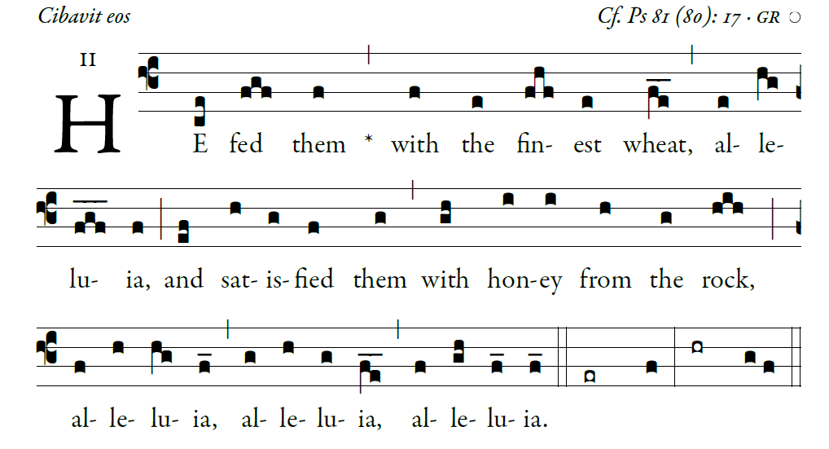
©Illuminare Publications.com

Sing joyfully to God our strength,
shout in triumph to the God of Jacob.
Raise a song and sound the timbrel,
the sweet-sounding harp and the lute;

Blow the trumpet at the new moon,
when the moon is full, on our feast.
For this is a statute in Israel,
a command of the God of Jacob.

I am the LORD your God,
who brought you up from the land of Egypt.
Open wide your mouth, and I will fill it.

The Lord Have Mercy and Gloria are found the
Yellow program ORBIS FACTOR MASS XI

RESPONSORIAL PSALM

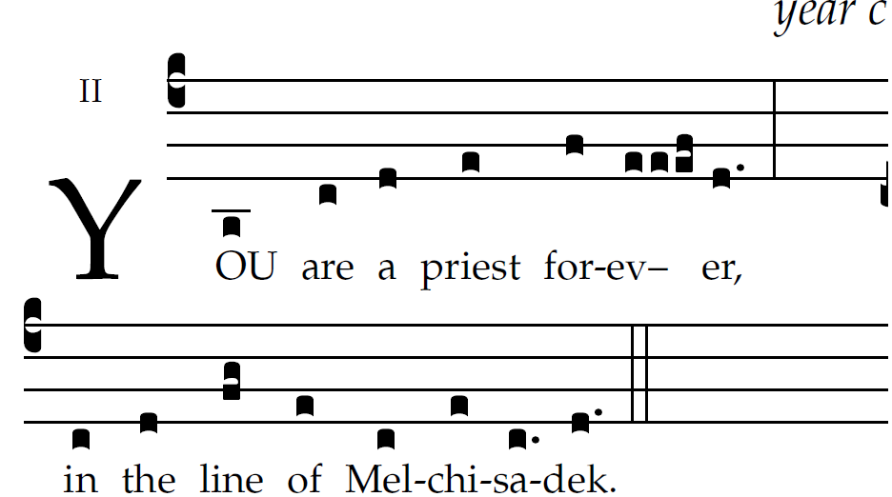

The LORD said to my Lord:
"Sit at my right hand
till I make your enemies your footstool." 
The scepter of your power the LORD
will stretch forth from Zion:
"Rule in the midst of your enemies."   
"Yours is princely power in the day of your birth,
in holy splendor;before the daystar,
like the dew, I have begotten you." 
The LORD has sworn, and he will not repent:
"You are a priest forever,
according to the order of Melchizedek."         

SEQUENCE: Laud, O Sion Your Salvation

ALLELUIA.
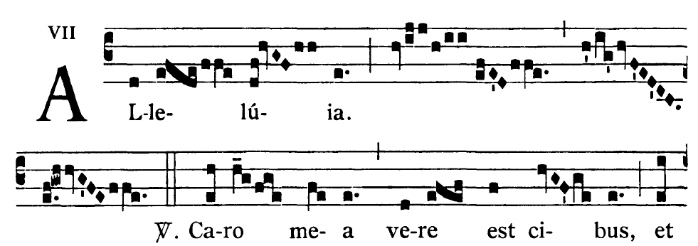
I am the living bread that came down from heaven,says the Lord;
whoever eats this bread will live forever

OFFERTORY HYMN :
“JESUS MY LORD, MY GOD, MY ALL”

Jesus, my Lord, my God, my all!
How can I love Thee as I ought?
And how revere this wondrous gift,
So far surpassing hope or thought?
Refrain Sweet Sacrament, we Thee adore!
Oh, make us love Thee more and more.
Oh, make us love Thee more and more.
2. Had I but Mary's sinless heart
With which to love Thee, dearest King,
Oh, with what ever fervent praise,
Thy goodness, Jesus, would I sing!
3 . Thy Body, Soul and Godhead, all!
O mystery of love divine!
I cannot compass all I have,
For all Thou hast and art is mine!
“Holy,” and “Lamb of God” are found in the
Yellow program : MASS XI ORBIS FACTOR

