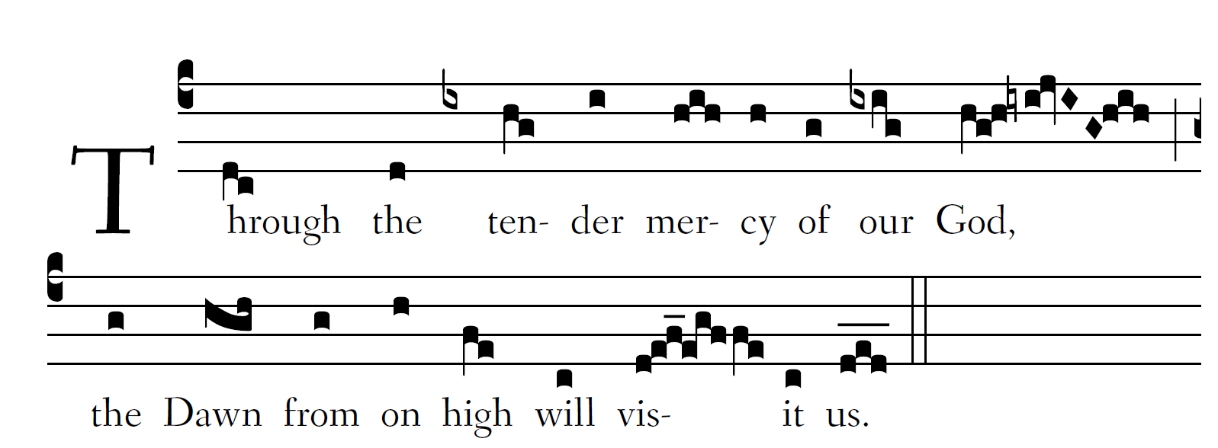
1

Fr.Columba Kelley @Saint Meinrad Archabbey

Blessed be the Lord, the |God of Is-ra-el,
because he has visited and wrought redemption | for his peo-ple,
and has raised up a horn of salva|tion for us
in the house of Dav-|id his ser-vant.

And you, O child, |shall be called
the prophet of | the Most High ;
for you shall go before | the Lord
to pre- |pare his ways.

To give his people knowledge |of sal-va-tion
through the forgiveness | of their sins,
because of the compassionate kindness of | our God
with which the Orient from on high will |vis-it us.

To shine on those who | sit in dark-ness
and the | sha- dow of death,
to guide | our feet
into the |way of peace.
