COMMUNION ANTIPHON

Psalm73 (72)
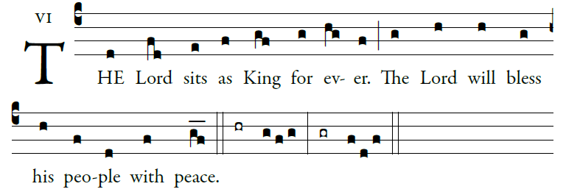
Illuminarepublications.com

Ascribe to the LORD, you heavenly powers,
ascribe to the LORD glory and strength.
Ascribe to the LORD the glory of his name;
bow down before the LORD, majestic in holiness.

The voice of the LORD upon the waters,
the God of glory thunders;
the LORD on the immensity of waters;
the voice of the LORD full of power;
the voice of the LORD full of splendor.

COMMUNION HYMN “ Be Not Afraid” #430

RECESSIONAL HYMN
“To Jesus Christ, Our Sovereign King” #729

The Solemnity Our Lord Jesus Christ,
King of the Universe YEAR A

ENTRANCE ANTIPHON

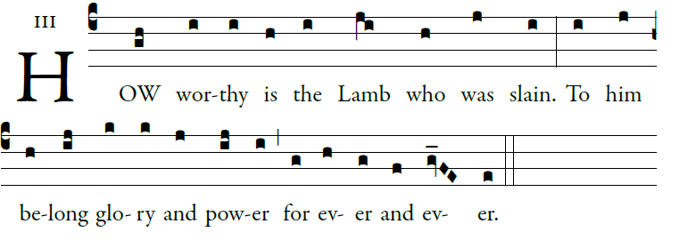
Illuminarepublication.com

O God, give your judgment to the king,
to a king’s son your justice,
that he may judge your people in justice,
and your poor in right judgment.

May the mountains bring forth peace for the
people, and the hills justice.
May he defend the poor of the people,
and save the children of the needy,
and crush the oppressor.

Glory be to the Father…

Musical settings for Lord have Mercy, Glory to God,
Holy & Acclamations, Lamb of God ,
Mass of St. Frances Cabrini. Music Issue #902-#911

RESPONSORIAL PSALM

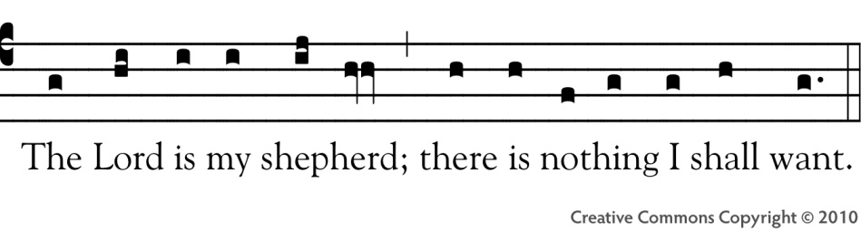
St. Noel Chabanel Responorial Psalms Project
The LORD is my shepherd; I shall not want.
In verdant pastures he gives me repose.
Beside restful waters he leads me;
he refreshes my soul.
He guides me in right paths
for his name's sake.
You spread the table before me
in the sight of my foes;
you anoint my head with oil;
my cup overflows.
Only goodness and kindness follow me
all the days of my life;
and I shall dwell in the house of the LORD
for years to come.

ALLELUIA

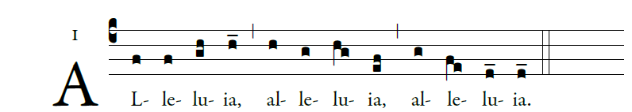
.
Blessed is he who comes in the name of the Lord!
Blessed is the kingdom of our father David that is to come!

OFFERTORY HYMN

We Praise Thee King of Kings.
(Dich König loben wir)
Text Angleus Silesius 1657
Music Georg Josef 1657


  

