COMMUNION ANTIPHON

Psalm73 (72)
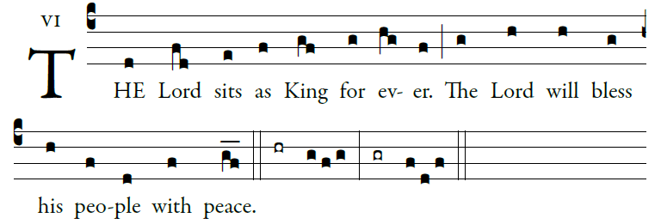
Illuminarepublications.com

Ascribe to the LORD, you heavenly powers,
ascribe to the LORD glory and strength.
Ascribe to the LORD the glory of his name;
bow down before the LORD, majestic in holiness.

The voice of the LORD upon the waters,
the God of glory thunders;
the LORD on the immensity of waters;
the voice of the LORD full of power;
the voice of the LORD full of splendor.

The voice of the LORD flashes flames of fire.
The voice of the LORD shakes the wilderness,
the LORD shakes the wilderness of Kadesh;

the voice of the LORD rends the oak tree
and strips the forest bare.
In his temple they all cry, “Glory!”

RECESSIONAL HYMN
“To Jesus Christ,\ Our Sovereign King”

The Solemnity Our Lord Jesus Christ,
King of the Universe
+
.

ENTRANCE ANTIPHON

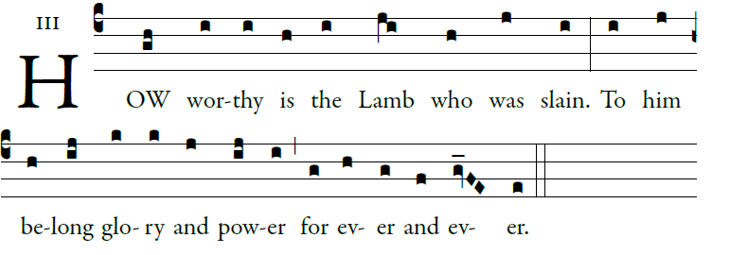
Illuminarepublication.com

O God, give your judgment to the king,
to a king’s son your justice,
that he may judge your people in justice,
and your poor in right judgment.

May the mountains bring forth peace for the
people, and the hills justice.
May he defend the poor of the people,
and save the children of the needy,
and crush the oppressor.

Glory be to the Father…

RESPONSORIAL PSALM

Ralph Bednarz 2015
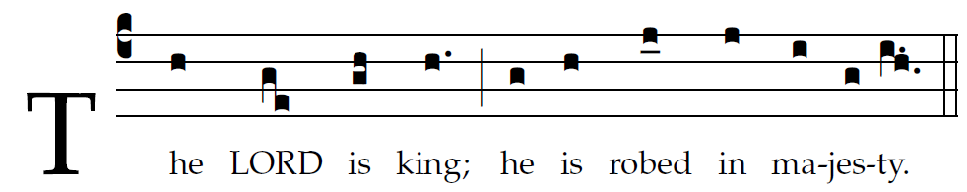
2

The LORD is king,
in splendor robed;
robed is the LORD
and girt about with strength.
And he has made the world firm,
not to be moved.
Your throne stands firm from of old;
from everlasting you are, O LORD.
Your decrees are worthy of trust indeed;
holiness befits your house,
O LORD, for length of days.

ALLELUIA

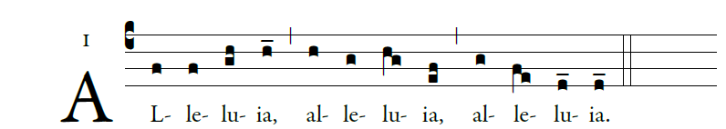
.
Blessed is he who comes in the name of the Lord!
Blessed is the kingdom of our father David that is to come!

OFFERTORY HYMN

We Praise Thee King of Kings.
(Dich König loben wir)
Text Angleus Silesius 1657
Music Georg Josef 1657


  

