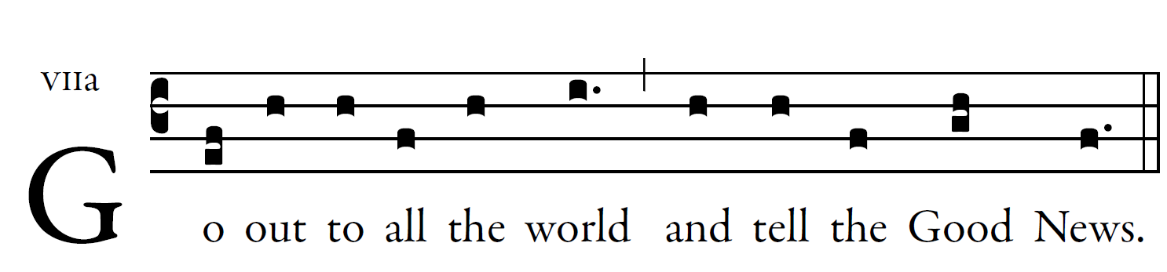

- Praise the Lord, all you nations ; *
glorify him, all you peoples. 

2. For steadfast is his kindness towards us, *
and the fidelity of the Lord endures forever.

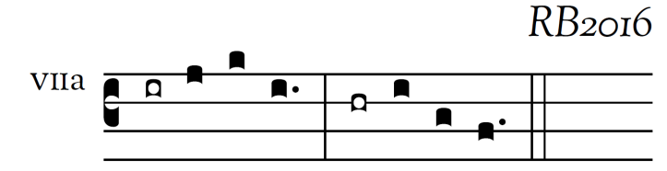
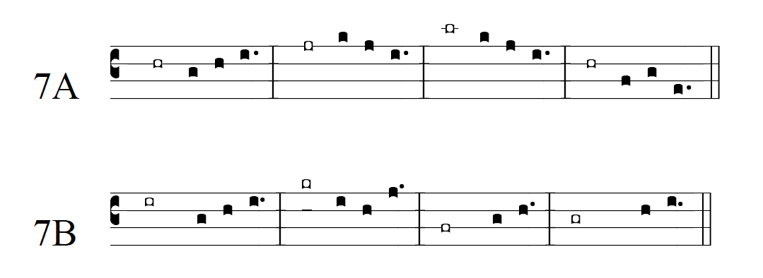
user-notes: ;
commentary: ;
annotation: VIIa ;
centering-scheme: english;
%fontsize: 12;
%spacing: smith;
%font: GaramondPremierPro;
%width: 4;
%height: 11;
%%
(c3)Go(ef) out(h) to(h) all(f) the(h) world(i.) (,) and(h) tell(h) the(f) Good(gh) News.(f.) (::)

