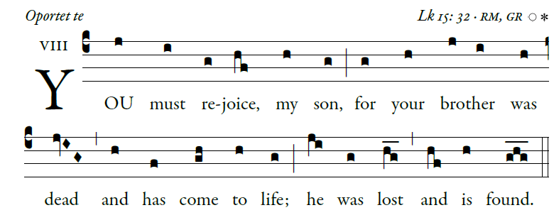

Blessed is he whose transgression is forgiven,
whose sin is remitted.
Blessed the man to whom the LORD imputes no guilt,
in whose spirit is no guile.

I kept it secret and my frame was wasted. [6]
I groaned all day long,
To you I have acknowledged my sin;
my guilt I did not hide.
I said, “I will confess my transgression to the LORD.”
And you have forgiven the guilt of my sin.
I will instruct you and teach you [5]
the way you should go;
I will fix my eyes up on you.
Rejoice in the LORD; exult, you just!
Ring out your joy, all you upright of heart!
