COMMUNION ANTIPHON

Fr. Columba Kelly © Saint Meinrad Archabbey
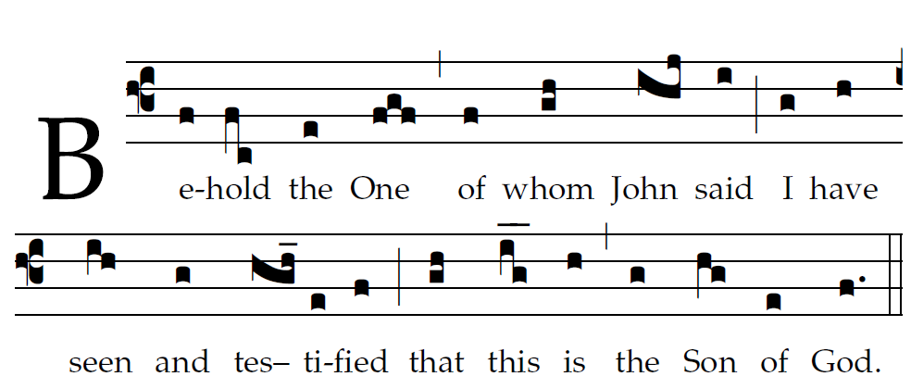

Ascribe to the LORD, you heavenly powers,
ascribe to the LORD glory and strength.
Ascribe to the LORD the glory of his name;
bow down before the LORD, majestic in holiness.

ANIMA CHRISTE

Soul of Christ, sanctify me
Body of Christ, save me
Blood of Christ, inebriate me
Water from the side of Christ, wash me
Passion of Christ, strengthen me
O good Jesus, hear me
Within Thy wounds hide me
Suffer me not to be separated from Thee
From the malignant enemy defend me
In the hour of my death call me
And bid me come unto Thee
That with thy Saints I may praise Thee Forever and ever.
Amen

RECESSIONAL HYMN

Baptism of the Lord year A

ENTRANCE HYMN
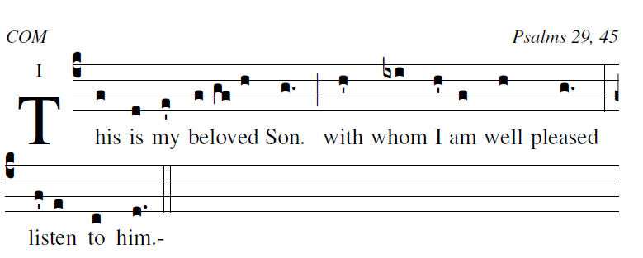
The voice of the LORD upon the waters,
the God of glory thunders;
the LORD on the immensity of waters;
⁴the voice of the LORD full of power;
the voice of the LORD full of splendor.

ANTIPHON (Sprinkling Rite)
RB
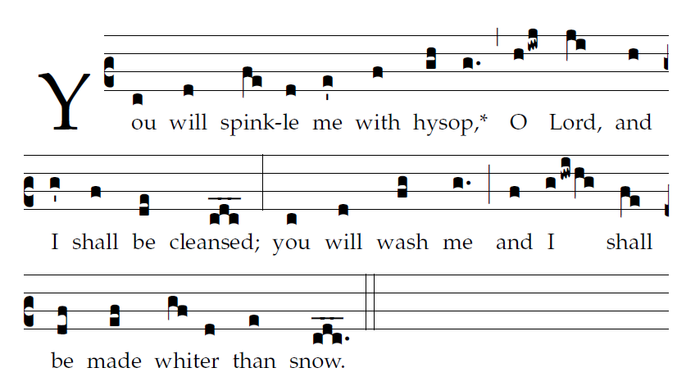
 Have mercy on me, O God, according to your great mercy
Glory be to the Father , and to the Son,
and to the Holy Spirit.
As it was in the beginning is now and evershal be Amen

RESPONSORIAL PSALM

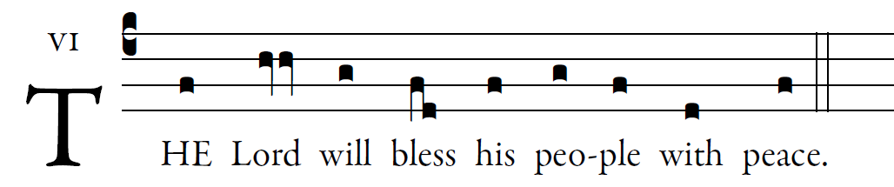 lluminarepublications.com

Give to the LORD, you sons of God,
give to the LORD glory and praise,
Give to the LORD the glory due his name;
adore the LORD in holy attire. 

The Lord will bless his people with peace.
The voice of the LORD is over the waters,
the LORD, over vast waters.
The voice of the LORD is mighty;
the voice of the LORD is majestic. 

The Lord will bless his people with peace.
The God of glory thunders,
and in his temple all say, “Glory!”
The LORD is enthroned above the flood;
the LORD is enthroned as king forever. 

ALLELUIA
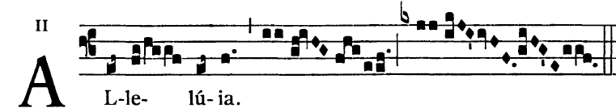

John said: One mightier than I is coming: He will baptize you with the Holy Spirit and with fire.

OFFERTORY : “ O Salutaris” “ O Saving Victim”

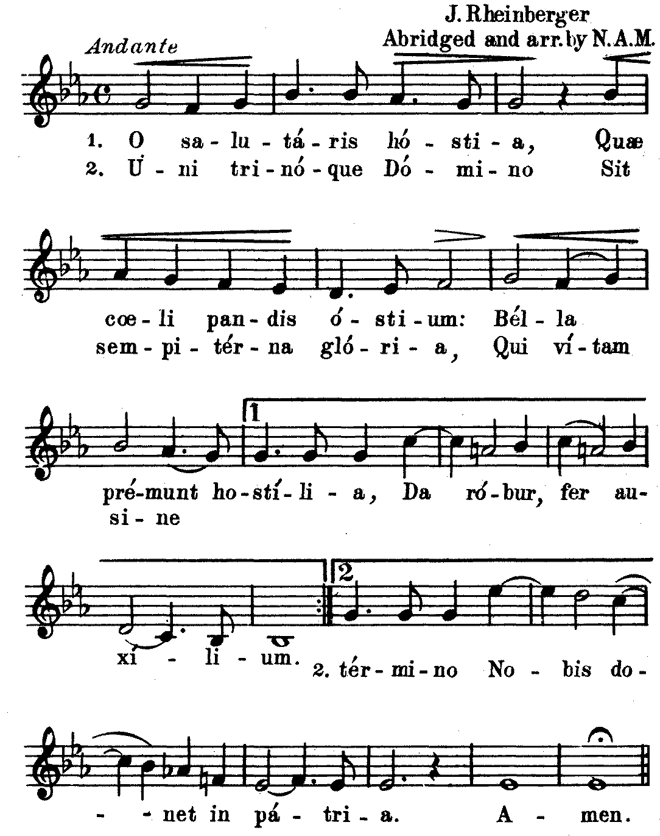

O saving Vicitim , opening wide the gate of heaven to us below. Our foes press on from every side. Thy aid supply, thy strength bstow. To Thy great name by endless praise,Immortal Godhead, one in Three; Oh, grant us endless length of days, In our true native land with Thee. Amen

