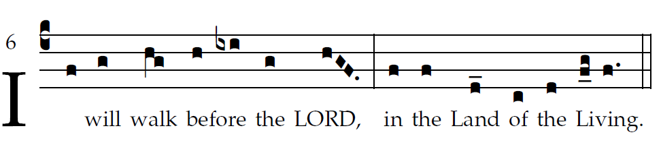

RB 2015

I love the LORD because *he has heard*  
my voice in *supplication,*  
Because he has inclined his *ear to me*  
the *day I called.*  
  
The cords of *death* *encompassed me;*  
the snares of the netherworld *seized upon me;*  
I fell into dis*tress and sorrow,*  
And I called upon the name *of the LORD,*  
“O LORD, *save my life!”*  
  
Gracious is the *LORD and just;*  
yes, our *God is merciful.*  
The LORD *keeps the* *little ones;*  
I was brought low, *and he saved me.*  
  
  
For he has freed my *soul from death,*  
my eyes from tears, my *feet from stumbling.*  
I shall walk before the Lord  
in the land *of the living.*

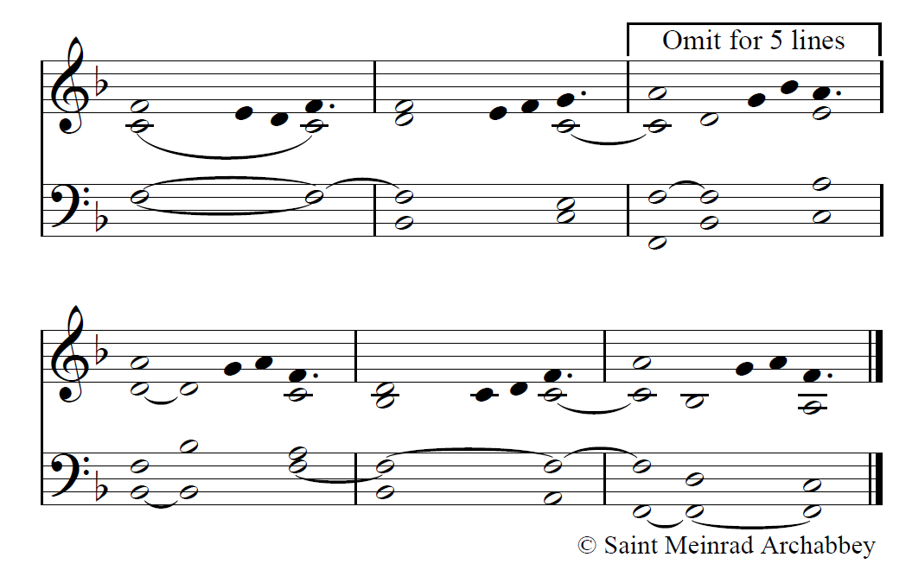

OCP

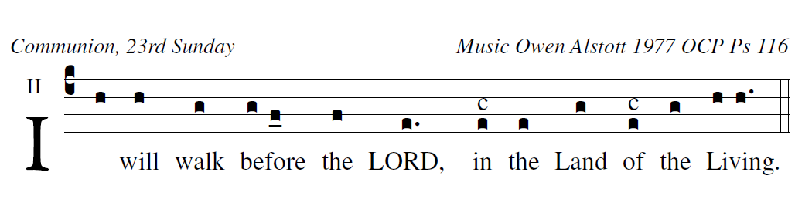

Responsorial Psalm Ps 114:1-2, 3-4, 5-6, 8-9

I love the LORD because *he has heard*  
my voice in supp*lication,*  
Because he has inclined his *ear to me*  
the *day I called.*

  
The cords of death en*compassed me;*  
the snares of the netherworld seized up*on me;*   
I fell into distr*ess and sorrow,*   
And I called upon the name of *the LORD,*

"O LORD, *save my life!"*



Gracious is the *LORD and just;*  
yes, our God *is merciful.*  
The LORD keeps the *little ones;*  
I was brought low, *and he saved me.*  
  
  
For he has freed my *soul from death,*  
my eyes from tears, my feet *from stumbling.*  
I shall walk bef*ore the Lord*  
in the land *of the living.*

user-notes: Communion, 23rd Sunday ;

commentary: Music Owen Alstott 1977 OCP Ps 116 ;

annotation: II ;

centering-scheme: english;

%spacing: vichi;

%font: times;

%width: 5;

%height: 11;

%%

(c4)I(h) will(h) walk(g) {be}fore(g/ f_0) the(f) LORD,(e.) (:) in(e[cs:c]) the(e) Land(g) of(e[cs:c]) the(g) {Li}ving.(h/ h.) (::)