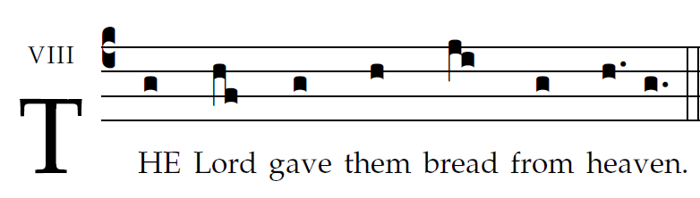

rb2015

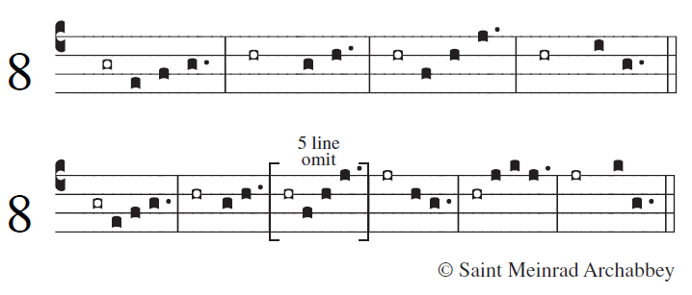
What we have heard and know,
and what our fathers have declared to us,
We will declare to the generation to come
the glorious deeds of the LORD and his strength
and the wonders that he wrought.
He commanded the skies above
and opened the doors of heaven;
he rained manna upon them for food
and gave them heavenly bread.
Man ate the bread of angels,
food he sent them in abundance.
And he brought them to his holy land,
to the mountains his right hand had won.
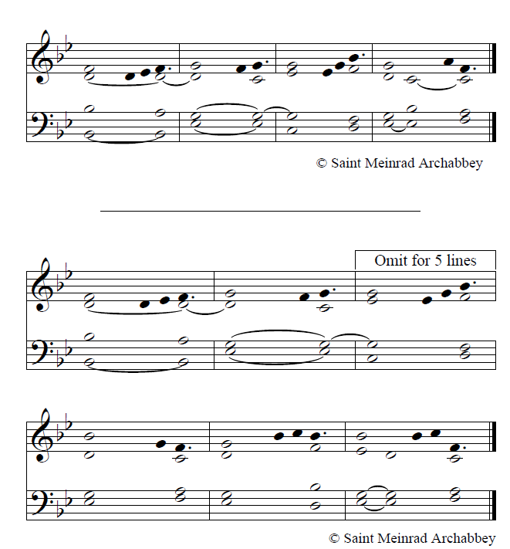

alt adapted from OCP 2012

