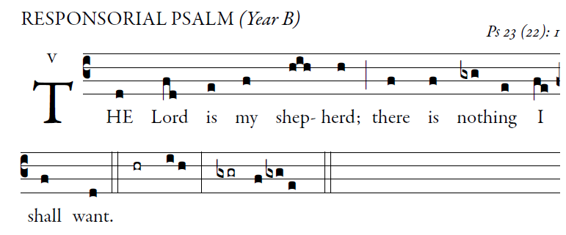 Antiphon, Illuminarepublications.com
The LORD is my shepherd; I shall not want.
In verdant pastures he gives me repose;
beside restful waters he leads me;
he refreshes my soul. 
He guides me in right paths
for his name’s sake.
Even though I walk in the dark valley
I fear no evil; for you are at my side
with your rod and your staff
that give me courage. 
You spread the table before me
in the sight of my foes;
you anoint my head with oil;
my cup overflows. 
Only goodness and kindness follow me
all the days of my life;
and I shall dwell in the house of the LORD
for years to come. 
