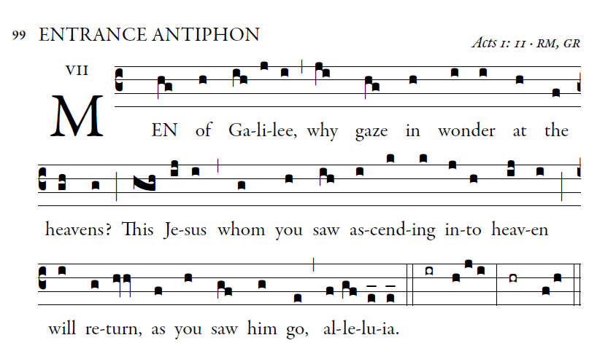
Illuminare publications.com

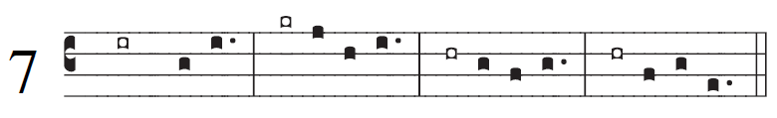

1. All peoples, clap your hands.
Cry to God with shouts of joy!
2. For the lord, the Most High, is awesome,
the great king over all the earth.

3. He humbles peoples under us
and nations under our feet.
4. Our heritage he chose for us,
the pride of Jacob whom he loves.

5. God goes up with shouts of joy.
e lord goes up with trumpet blast.
6. Sing praise for God; sing praise!
Sing praise to our king; sing praise!

