COMMUNION HYMN

Praise the Lord Ye Heavens Adore Him
(melody: “Alleluia Sing to Jesus”)

Praise the Lord! for he is glorious;
never shall his promise fail;
God hath made his saints victorious;
sin and death shall not prevail.
Praise the God of our salvation!
Hosts on high, his power proclaim;
heaven and earth, and all creation,
laud and magnify his Name

Praise the Lord: ye heavens, adore Him;
Praise Him, angels in the height.
Sun and moon, rejoice before Him;
Praise Him, all ye stars of light.
Praise the Lord, for He hath spoken;
Worlds His mighty voice obeyed.
Laws which never shall be broken
For their guidance He hath made.

RECESSIONAL HYMN

“Sing with All the Saints in Glory”

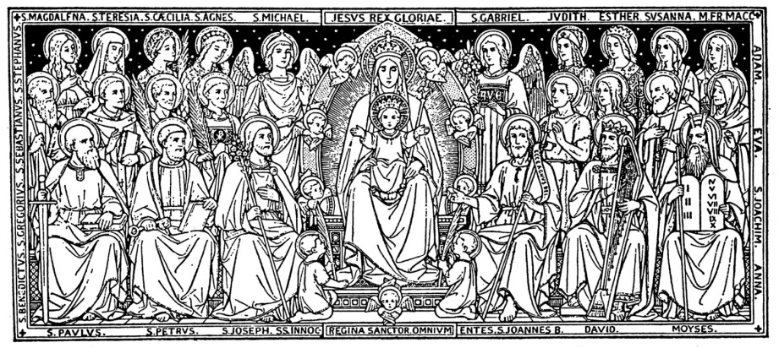

ALL SAINTS

ENTRANCE HYMN
“For All the Saints”

RESPONSORIAL PSALM

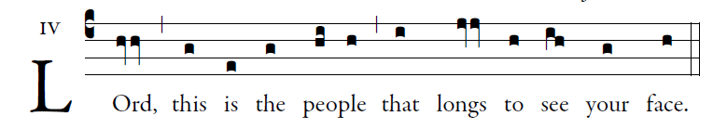

Adam Bartlett Illuminarepublications.com
The LORD's are the earth and its fullness;
the world and those who dwell in it.
For he founded it upon the seas
and established it upon the rivers.

Who can ascend the mountain of the LORD?
or who may stand in his holy place?
One whose hands are sinless, whose heart is clean,
who desires not what is vain.
He shall receive a blessing from the LORD,
a reward from God his savior.
Such is the race that seeks him,
that seeks the face of the God of Jacob.

ALLELUIA
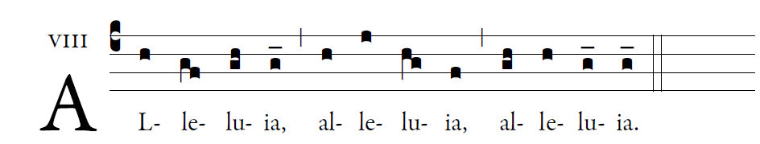

OFFERTORY ANTIPHON

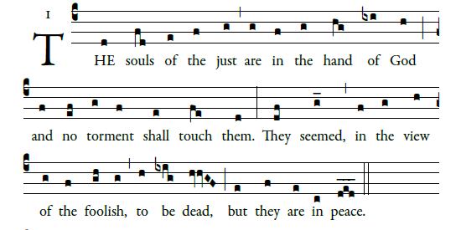
͡©illminarepublications.com

For if to others, indeed, they seem punished,
yet is their hope full of immortality;
Chastised a little, they shall be greatly blessed,
because God tried them
and found them worthy of himself.

As gold in the furnace, he proved them,
and as sacrificial offerings* he took them to himself.

In the time of their judgment* they shall shine
and dart about as sparks through stubble;
They shall judge nations and rule over peoples,
and the LORD shall be their King forever.

Those who trust in him shall understand truth,
and the faithful shall abide with him in love:
Because grace and mercy are with his holy ones,
and his care is with the elect
