COMMUNION ANTIPHON
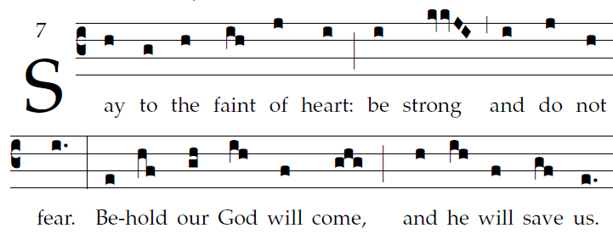

Fr. Coluba Kelly © Saint Meinrad Archabbey
ISAIAH 35
The wilderness and the parched land will exult;
the Arabah will rejoice and bloom;
Like the crocus it shall bloom abundantly,
and rejoice with joyful song.

The glory of Lebanon will be given to it,
the splendor of Carmel and Sharon;
They will see the glory of the LORD,
the splendor of our God.

COMMUNION HYMN:

“ Wake, O Wake, And Sleep No Longer”

RECESSIONAL HYMN

“O Come, O Come Emmanuel.”

THIRD SUNDAY of ADVENT
.

ENTRANCE ANTIPHON ©CMMA Adam Bartlett

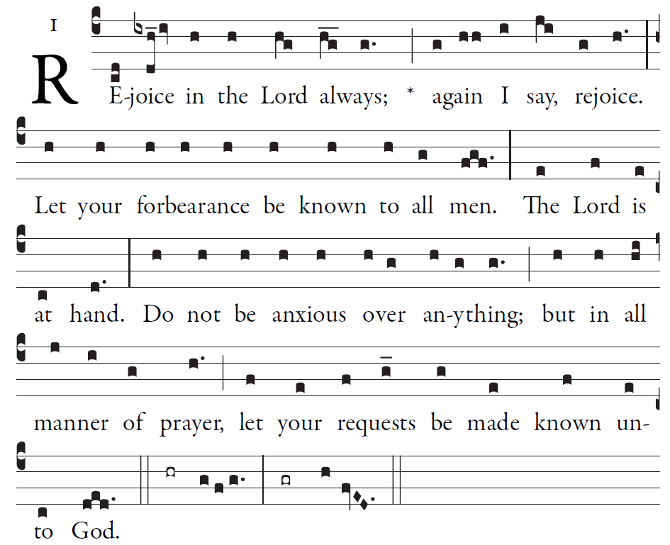

O LORD, you have favored your land,
and brought back the captives of Jacob.
Will you not restore again our life,
that your people may rejoice in you?

Bring us back, O God, our savior!
Put an end to your grievance against us.
Will you be angry with us forever?
Will your anger last from age to age?

RESPONSORIAL

©Illuminarepublications.com

My soul proclaims the greatness of the Lord;
my spirit rejoices in God my Savior,
for he has looked upon his lowly servant.
From this day all generations will call me blessed:
R. My soul rejoices in my God.
the Almighty has done great things for me,
and holy is his Name.
He has mercy on those who fear him
in every generation.
R. My soul rejoices in my God.
He has filled the hungry with good things,
and the rich he has sent away empty.
He has come to the help of his servant Israel
for he has remembered his promise of mercy.

OFFERTORY ANTIPHON

©CMMA Adam Bartlett

You forgave the guilt of your people,
and covered all their sins.
You averted all your rage;
you turned back the heat of your anger.

Bring us back, O God, our savior!
Put an end to your grievance against us.
Will you be angry with us forever?
Will your anger last from age to age?

REJOICE

