COMMUNION ANTIPHON
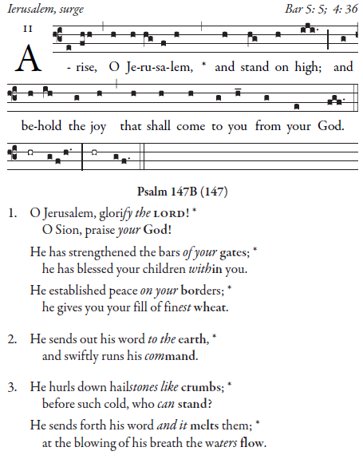
Simple English Propers by Adam Bartlett is licensed under a Creative Commons
Attribution 4.0 International License.Based on a work at http://musicasacra.com/sep.

RECESSIONAL HYMN

“Creator of the Stars of Night”

SECOND SUNDAY OF ADVENT
YEAR A

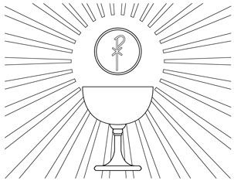

Out of Zion his perfect beauty shines forth.
God is coming in broad daylight.
Summon before Him the consecrated nation
Who made a covenant with Him by sacrifice.

Gradual for the 2nd Sunday in Advent

ENTRANCE ANTIPHON

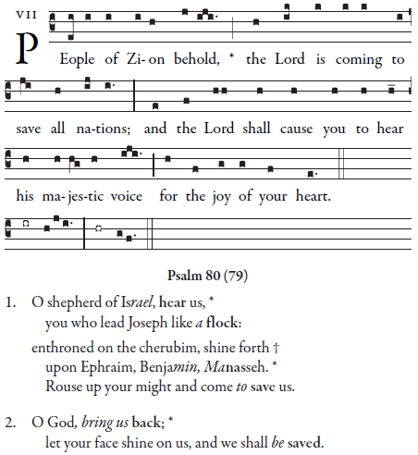

Simple English Propers by Adam Bartlett is licensed under a Creative Commons Attribution 4.0 International License.Based on a work at http://musicasacra.com/sep.

RESPONSORIAL PSALM
From Today’s Missal

ALLELUIA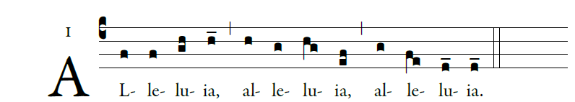

illuminarepublications.com

OFFERTORY 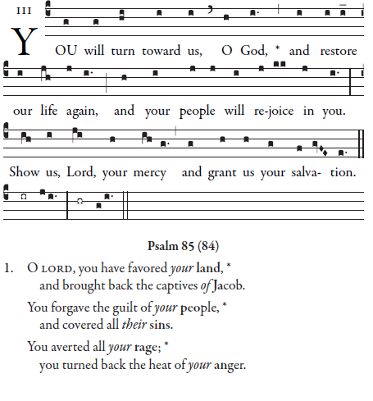
Simple English Propers by Adam Bartlett is licensed under a Creative Commons Attribution 4.0 International License.Based on a work at http://musicasacra.com/sep.

