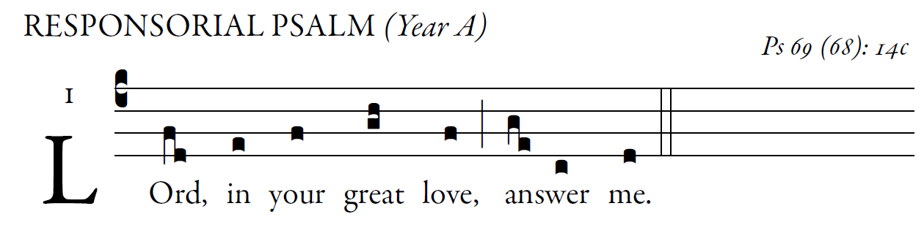

For your sake I bear insult,
and shame covers my face.
I have become an outcast to my brothers,
a stranger to my children,
Because zeal for your house consumes me,
and the insults of those who blaspheme you fall upon me.
I pray to you, O LORD,
for the time of your favor, O God!
In your great kindness answer me
with your constant help.
Answer me, O LORD, for bounteous is your kindness;
in your great mercy turn toward me.
"See, you lowly ones, and be glad;
you who seek God, may your hearts revive!
For the LORD hears the poor,
and his own who are in bonds he spurns not.
Let the heavens and the earth praise him,
the seas and whatever moves in them!''
