Weekly music programs are available at
www.gregorianchant.weebly.com
_

Seventh Sunday
in Ordinary Time (year A)

ENTRANCE HYMN
_

_
_
_
_
_

KYRIE #902 MI (optional)

GLORIA: Mass of St Francis Cabrini #903 MI

RESPONSORIAL PSALM \

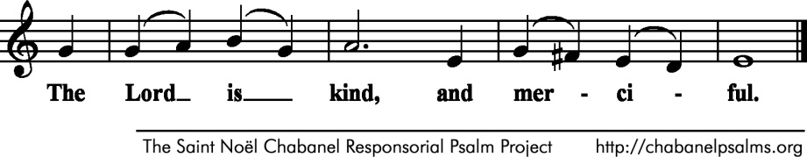

Bless the LORD, O my soul;
and all my being, bless his holy name.
Bless the LORD, O my soul,
and forget not all his benefits.
 The Lord is kind and merciful.
He pardons all your iniquities,
heals all your ills.
He redeems your life from destruction,
crowns you with kindness and compassion.
. The Lord is kind and merciful.
Merciful and gracious is the LORD,
slow to anger and abounding in kindness.
Not according to our sins does he deal with us,
nor does he requite us according to our crimes.
. The Lord is kind and merciful.
As far as the east is from the west,
so far has he put our transgressions from us.
As a father has compassion on his children,
so the LORD has compassion on those who fear him.

ALLELUIA

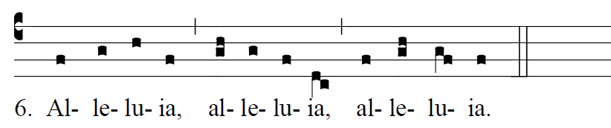

                            Whoever keeps the word of Christ,
the love of God is truly perfected in him.

OFFERTORY HYMN
“At that First Eucharist” 366 MI

Mass of St. Francis Cabrini : #906 - #911 MI
Holy, Acclamation, Amen, Lamb of God.

COMMUNION ANTIPHON
“Dwelling Place” #487 MI

RECESSIONAL HYMN:
“ Faith Hope and Love” #484 MI

