COMMUNION ANTIPHON Fr, Columba Kelley©Saint MeinradArchabbey

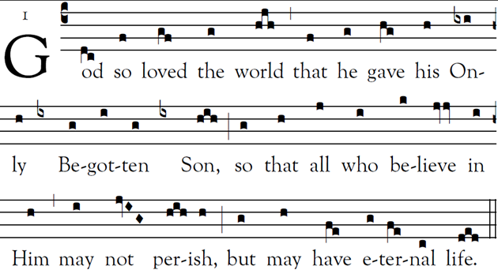

All sing

It is the LORD who forgives all your sins,
who heals every one of your ills,
who redeems your life from the grave,
who crowns you with mercy and compassion,
who fills your life with good things,
renewing your youth like an eagle’s.

The LORD is compassionate and gracious,
slow to anger and rich in mercy.
He will not always find fault;
nor persist in his anger forever.

AVE REGIA CAELORUM
RECESSIONAL HYMN:
“ Praise God From Whom All Blessings Flow”

SIXTH SUNDAY
in Ordinary Time (year C)

All sing

In you, O LORD, I take refuge.
Let me never be put to shame.
In your justice, set me free;
incline your ear to me, and speedily rescue me.
Be a rock of ref- uge for me,
a mighty strong- hold to save me.
For you are my rock, my stronghold!
Lead me, / guide me, / for the sake of your name.

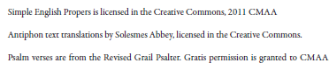

ORDINAY OF THE MASS
Chants of the Mass in english (ICEL) except the Agnus Dei,
found in “TODAY”S MISSAL” within the text of the Mass

OFFERTORY HYMN

GOD OF MERCY Heathland

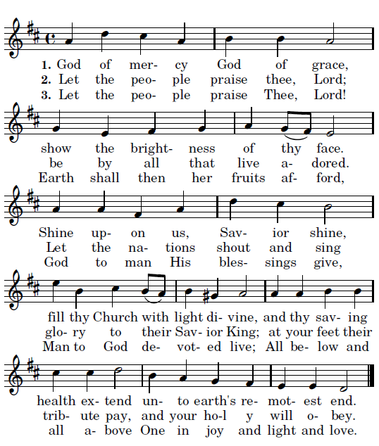

AGNUS DEI

