LUKE 4:28 When the people in the synagogue heard this, they were all filled with fury They rose up, drove him out of the town,
Those who see me in the street
flee from me.
I am forgotten, like someone dead,
and have become like a broken vessel.

I have heard the slander of the crowd;
terror all around me,
as they plot together against me,
as they plan to take my life.

But as for me, I trust in you, O LORD;
I say, “You are my God.
My lot is in your hands, deliver me
from the hands of my enemies
and those who pursue me.

Love the LORD, all you his saints.
The LORD guards the faithful.
Be strong, let your heart take courage,
all who hope in the LORD.

Simple English Ppropers ©CMAA Adam Bartlet

RECESSIONAL HYMN
“O God, Beyond all Praising”

Fourth Sunday
in Ordinary Time YEAR C
2019

ENTRANCE ANTIPHON

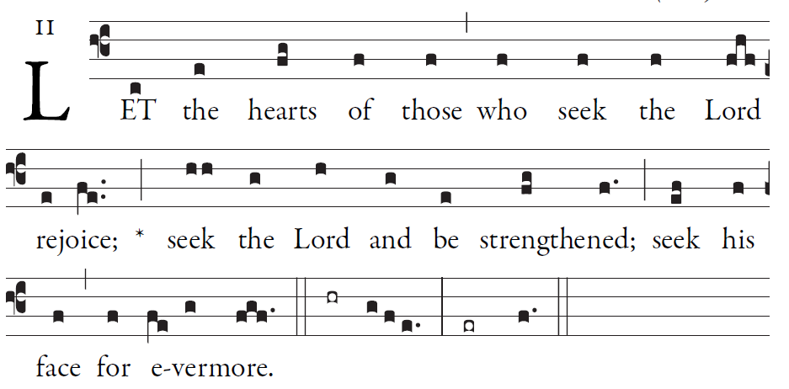
Simple English Ppropers ©CMAA Adam Bartlet
Simple English Propers is licensed in the Creative Commons, 2011 CMAA

PSALM 104 (105)
Give thanks to the LORD; proclaim his name.
Make known his deeds among the peoples.
O sing to him, sing his praise;
tell all his wonderful works!
Glory in his holy name;
let the hearts that seek the LORD rejoice.

Remember the wonders he has done,
his marvels and his words of judgment.
O children of Abraham, his servant,
O descendants of the Jacob he chose,
he, the LORD, is our God;
his judgments are in all the earth.
.

RESPONSORIAL PSALM
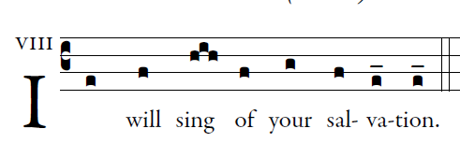

In you, O LORD, I take refuge; PSALM 71
let me never be put to shame.
In your justice rescue me, and deliver me;
incline your ear to me, and save me.
Be my rock of refuge,
a stronghold to give me safety,
for you are my rock and my fortress.
O my God, rescue me from the hand of the wicked.
For you are my hope, O Lord;
my trust, O God, from my youth.
On you I depend from birth;
from my mother’s womb you are my strength.
My mouth shall declare your justice,
day by day your salvation.
O God, you have taught me from my youth,
and till the present I proclaim your wondrous deeds.

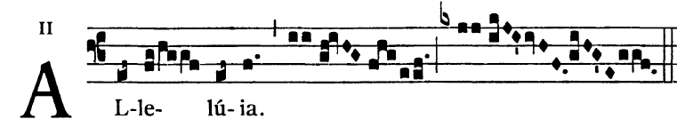

The Lord sent me to bring glad tidings to the
poor, to proclaim liberty to captives

BLESSING OF THROATS “ Hold Me in Life”
#595 GP

OFFERTORY HYMN:
“ Holy, Holy, Holy”

COMMUNION ANTIPHON

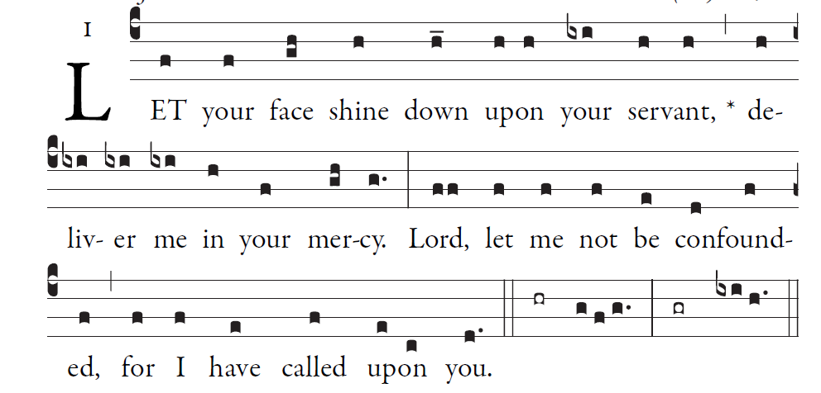

In you, O LORD, I take refuge; PSALM 31
let me never be put to shame.
In your justice rescue me, and deliver me;
incline your ear to me, and save me.
Be my rock of refuge,
a stronghold to give me safety,
for you are my rock and my fortress.
O my God, rescue me from the hand of the wicked.
Because of all my foes
I have become a reproach,
an object of scorn to my neighbors
and of fear to my friends.

