SANCTUS

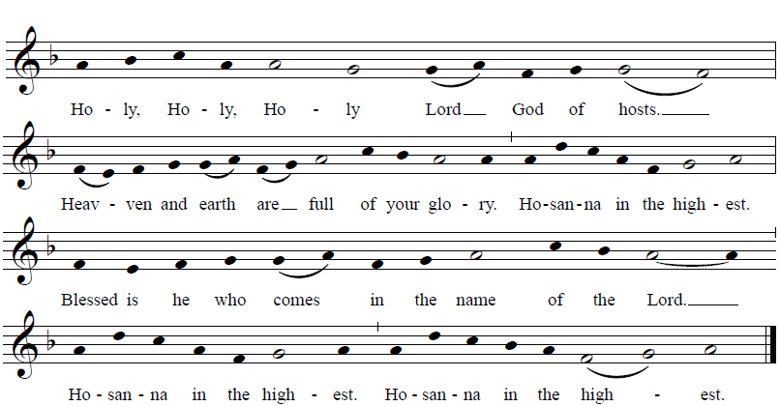
© 2014 Richard J. Clark | rjcceciliamusic.com
ACCLAMATION
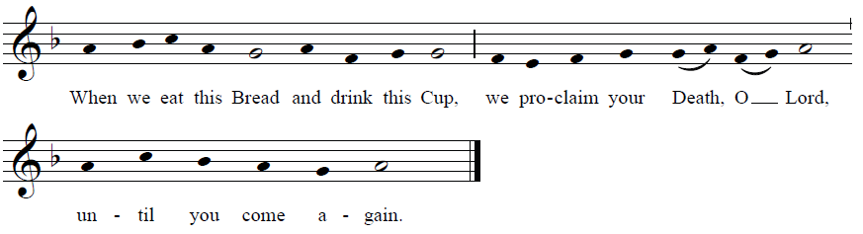

COMMUNION ANTIPHON

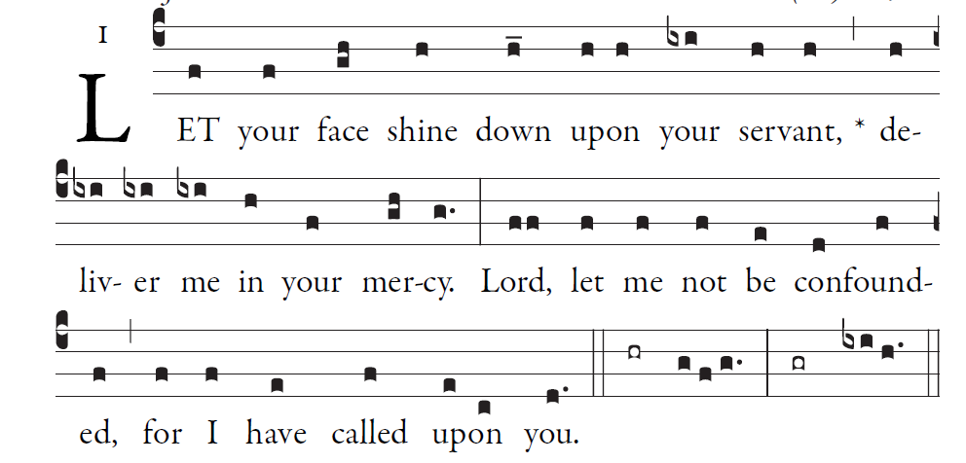
Simple English Ppropers ©CMAA Adam Bartlet

RECESSIONAL HYMN “To Jesus Christ Our Sovereign King”

Fourth Sunday
in Ordinary Time YEAR C

ENTRANCE ANTIPHON

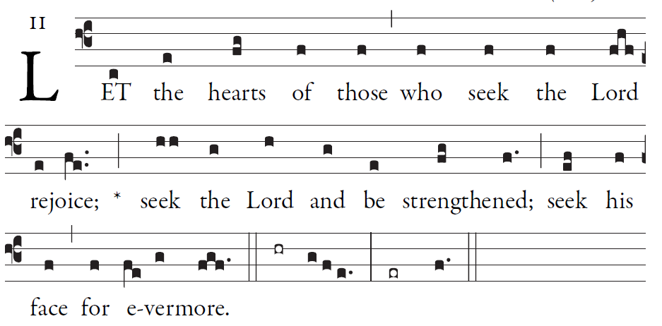
Simple English Ppropers ©CMAA Adam Bartlet
Simple English Propers is licensed in the Creative Commons, 2011 CMAA

 Give thanks to the LORD; proclaim his name.
Make known his deeds among the peoples.

KYRIE
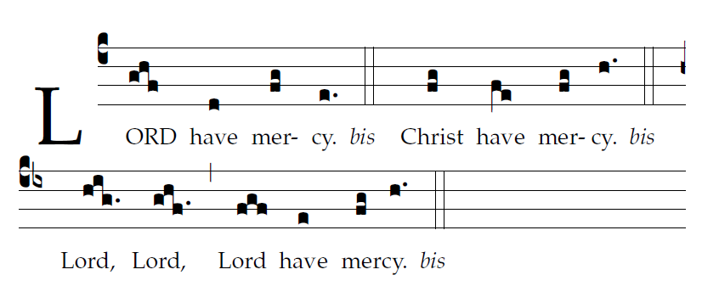
ORDINARY Mass of St. John Paull II ©Richard Clark used with permission
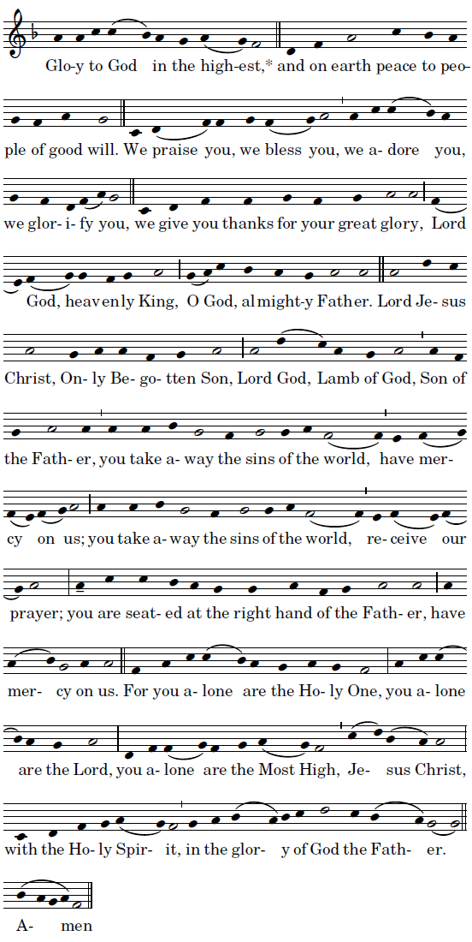
RESPONSORIAL PSALM
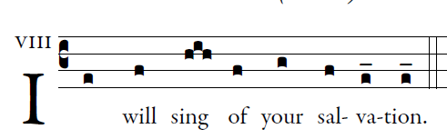

In you, O LORD, I take refuge;
let me never be put to shame.
In your justice rescue me, and deliver me;
incline your ear to me, and save me.
Be my rock of refuge,
a stronghold to give me safety,
for you are my rock and my fortress.
O my God, rescue me from the hand of the wicked.
For you are my hope, O Lord;
my trust, O God, from my youth.
On you I depend from birth;
from my mother’s womb you are my strength.
My mouth shall declare your justice,
day by day your salvation.
O God, you have taught me from my youth,
and till the present I proclaim your wondrous deeds.

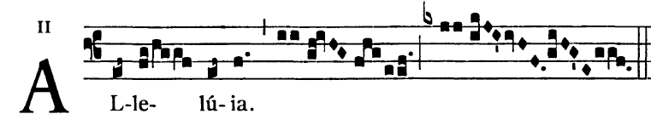

The Lord sent me to bring glad tidings to the poor,
to proclaim liberty to captives

OFFERTORY HYMN:
“ O Jesus Joy of Loving Hearts”

