COMMUNION ANTIPHON:
SIMPLE ENGLISH PROPERS
ADAM BARTLETT © CMAA.COM

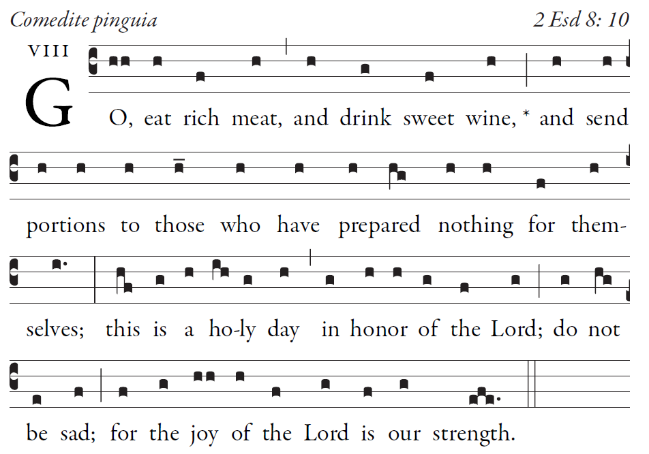

Sing joyfully to God our strength,
shout in triumph to the God of Jacob.
³Raise a song and sound the timbrel,
the sweet-sounding harp and the lute;

⁵For this is a statute in Israel,
a command of the God of Jacob.

I am the Lord your God,
who brought you up from the land of Egypt.
Open wide your mouth, and I will fill it.

RECESSIONAL HYMN:
“Christ be Our Light ”

THIRD SUNDAY
in ORDINARY TIME YEAR C

ENTRANCE ANTIPHON:
SIMPLE ENGLISH PROPERS
ADAM BARTLETT © CMAA.COM

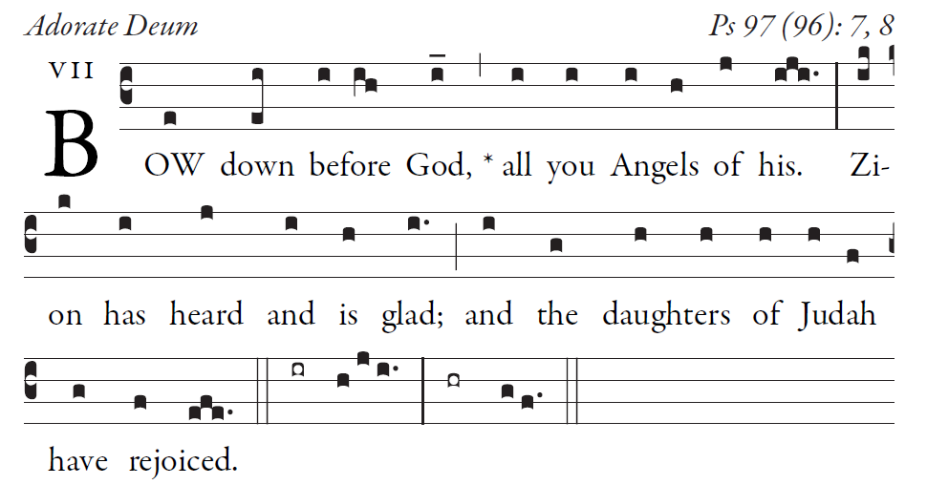

The heavens declare the glory of God,
and the firmament proclaims the work of his hands.
Day unto day conveys the message,
and night unto night imparts the knowledge.

No speech, no word, whose voice goes unheeded;
their sound goes forth through all the earth,
their message to the utmost bounds of the world.

There he has placed a tent for the sun;
it comes forth like a bridegroom coming from his tent,
rejoices like a champion to run his course.

.

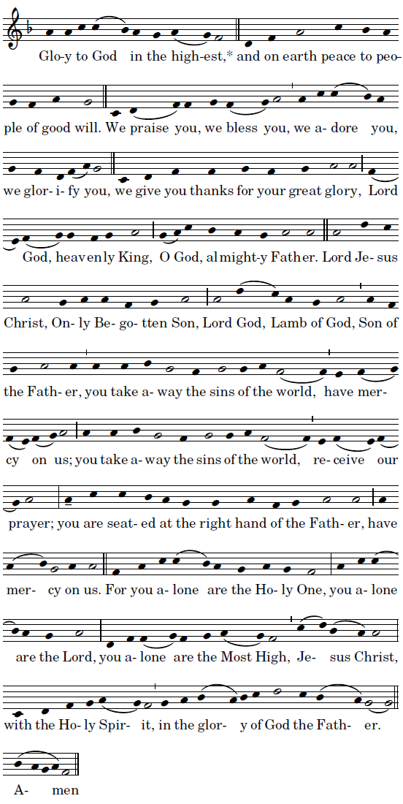
Mass of St John Paul II ©Richard Clark
RESPONSORIAL PSALM

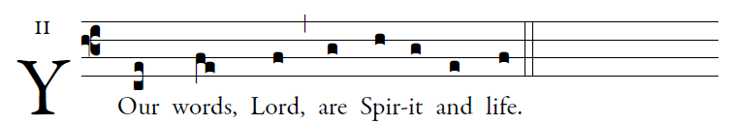

The law of the LORD is perfect,
refreshing the soul;
The decree of the LORD is trustworthy,
giving wisdom to the simple. 
The precepts of the LORD are right,
rejoicing the heart;
The command of the LORD is clear,
enlightening the eye. 
The fear of the LORD is pure,
enduring forever;
The ordinances of the LORD are true,
all of them just. 
Let the words of my mouth and the thought of my heart
find favor before you,
O LORD, my rock and my redeemer. 

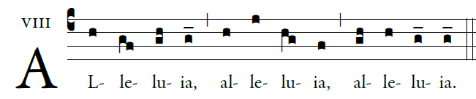
 
 The Lord sent me to being glad tidings to the poor,
and to proclaim liberty to captives.

OFFERTORY HYMN
“ Lift Up Your Heads, Ye Mighty Gates”
__

