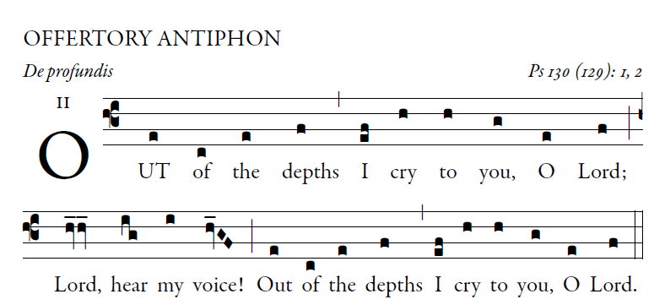
illuminarepublications.com

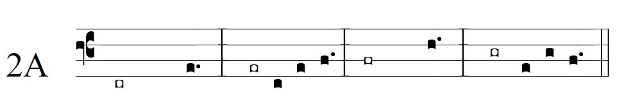

O let your ears be attentive
to the sound of my pleadings.
If you, O LORD, should mark iniquities,
LORD, who could stand?

But with you is found forgiveness,
that you may be revered.
I long for you, O LORD,
my soul longs for his word.

My soul hopes in the LORD
more than watchmen for daybreak.
More than watchmen for daybreak,
let Israel hope for the LORD.

For with the LORD there is mercy,
in him is plentiful redemption.
It is he who will redeem Israel
from all its iniquities.
