COMMUNION ANTIPHON
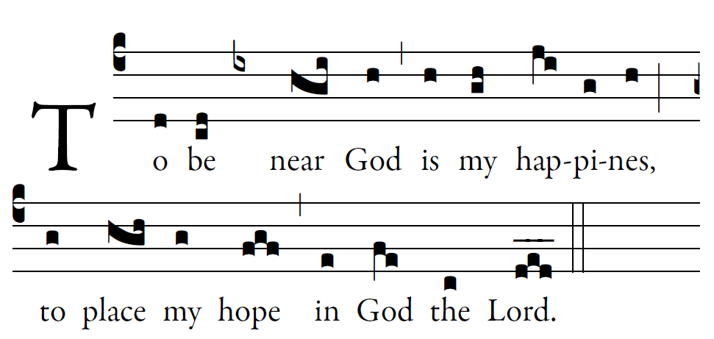
Fr. Columba Kelly © Saint Meinrad Archabbey

Psalm73 (72)
How good is God to Israel,
to those who are pure of heart!
As for me, I came close to stumbling;
my feet had almost slipped,

And so when my heart grew embittered,
and I was pierced to the depths of my being,
I was stupid and did not understand;
I was like a beast in your sight.

As for me, I was always in your presence;
you were holding me by my right hand.
By your counsel you will guide me,
and then you will lead me to glory.

What else have I in heaven but you?
Apart from you, I want nothing on earth.
My body and my heart waste away;
God is the strength of my heart;
God is my portion forever.

RECESSIONAL HYMN
“All is Well with My Soul”

33rd SUNDAY IN ORDINARY TIME
YEAR C

The Lord said,
I think thoughts of peace and not of affliction.
You will call upon me
and I will answer you
and
I will lead back your captives
from every place.

Entrance Antiphon

ENTRANCE HYMN “You are Mine”

RESPONSORIAL PSALM
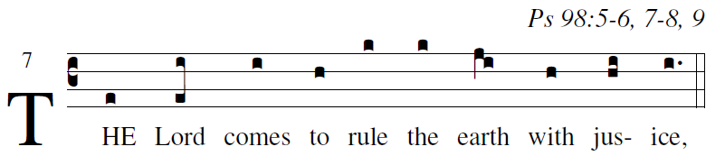

Sing praise to the LORD with the harp,
with the harp and melodious song.
With trumpets and the sound of the horn
sing joyfully before the King, the LORD.
Let the sea and what fills it resound,
the world and those who dwell in it;
let the rivers clap their hands,
the mountains shout with them for joy.
Before the LORD, for he comes,
for he comes to rule the earth,
He will rule the world with justice
and the peoples with equity.

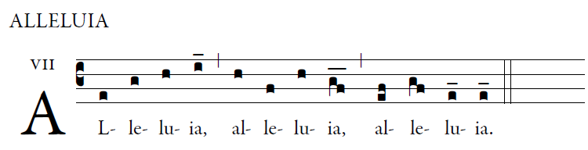

Stand erect and raise your heads
Because your redeption is at hand. 

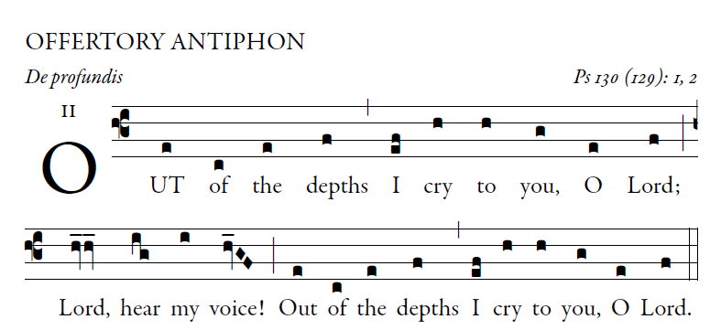
Illulminarepublication.com

O let your ears be attentive
to the sound of my pleadings.
If you, O LORD, should mark iniquities,
LORD, who could stand?

But with you is found forgiveness,
that you may be revered.
I long for you, O LORD,
my soul longs for his word.

My soul hopes in the LORD
more than watchmen for daybreak.
More than watchmen for daybreak,
let Israel hope for the LORD.

For with the LORD there is mercy,
in him is plentiful redemption.
It is he who will redeem Israel
from all its iniquities.

