COMMUNION ANTIPHON
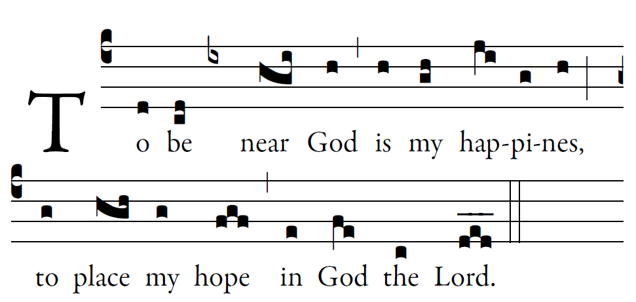
Fr. Columba Kelly © Saint Meinrad Archabbey

Psalm73 (72)

How good is God to Israel,
to those who are pure of heart!
As for me, I came close to stumbling;
my feet had almost slipped,

And so when my heart grew embittered,
and I was pierced to the depths of my being,
I was stupid and did not understand;
I was like a beast in your sight.

As for me, I was always in your presence;
you were holding me by my right hand.
By your counsel you will guide me,
and then you will lead me to glory.

What else have I in heaven but you?
Apart from you, I want nothing on earth.
My body and my heart waste away;
God is the strength of my heart;
God is my portion forever.

RECESSIONAL HYMN
“Come Ye Thankful People Come”

33rd SUNDAY IN ORDINARY TIME
.

ENTRANCE ANTIPHON

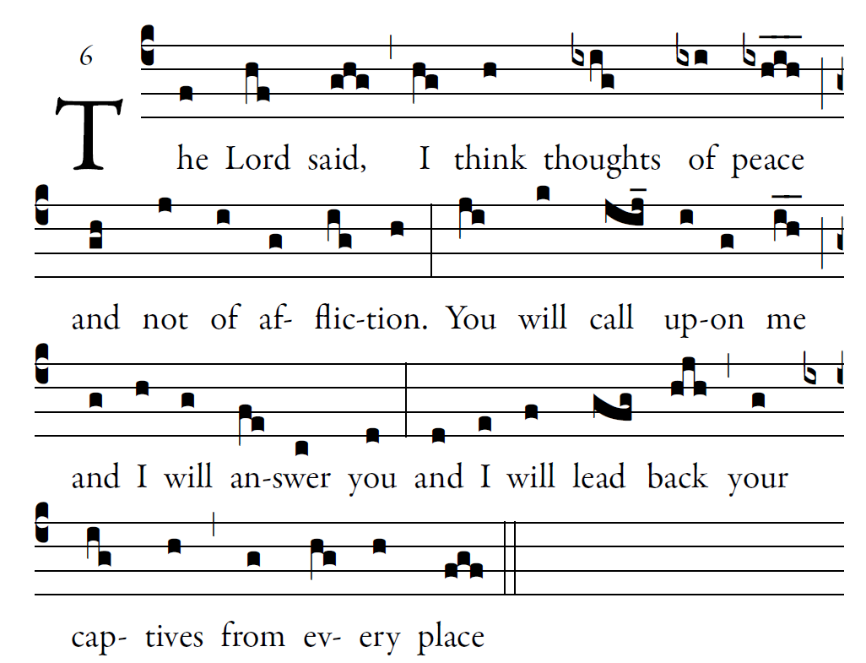

Fr. Columba Kelly © Saint Meinrad Archabbey

O Lord, you have favored your land,
and brought back the captives of Jacob.
You forgave the guilt of your people,
and covered all their sins.

You averted all your rage;
you turned back the heat of your anger.
Bring us back, O God, our savior!
Put an end to your grievance against us.
Let us see, O Lord, your mercy, *
and grant us your salvation.

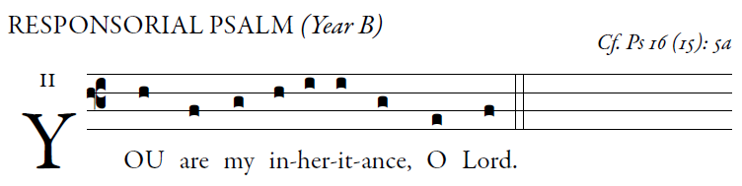

O LORD, my allotted portion and my cup,
you it is who hold fast my lot.
I set the LORD ever before me;
with him at my right hand I shall not be disturbed.

Therefore my heart is glad and my soul rejoices,
my body, too, abides in confidence;
because you will not abandon my soul
to the netherworld,
nor will you suffer your faithful one
to undergo corruption.

You will show me the path to life,
fullness of joys in your presence,
the delights at your right hand forever.

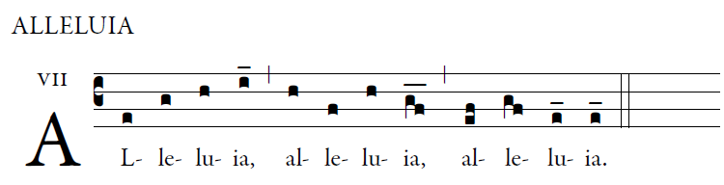

Be vigilant at all times
and pray that you have the strength
to stand before the Son of Man.

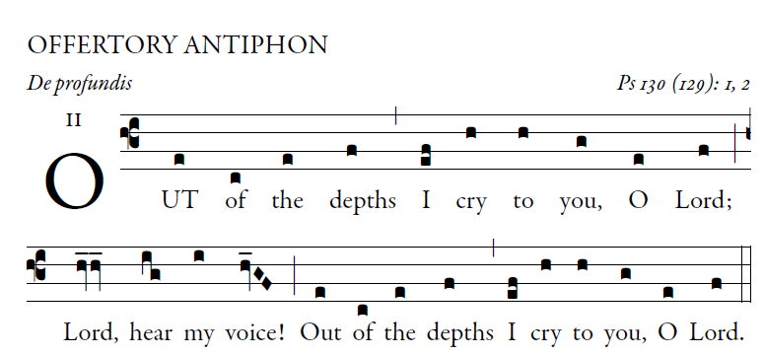

O let your ears be attentive
to the sound of my pleadings.
If you, O LORD, should mark iniquities,
LORD, who could stand?

But with you is found forgiveness,
that you may be revered.
I long for you, O LORD,
my soul longs for his word.

My soul hopes in the LORD
more than watchmen for daybreak.
More than watchmen for daybreak,
let Israel hope for the LORD.

For with the LORD there is mercy,
in him is plentiful redemption.
It is he who will redeem Israel
from all its iniquities.

