Congregation’s refrain

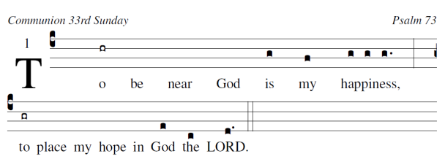

Choir’s refrain

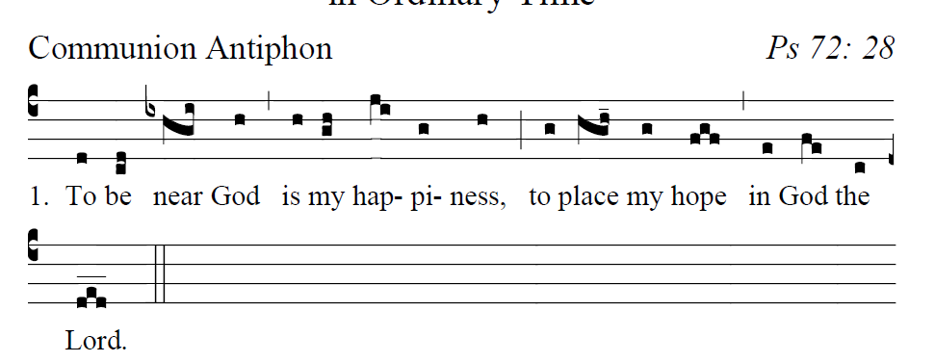
.
͡͡͡__
͡͡͡__
͡͡͡__

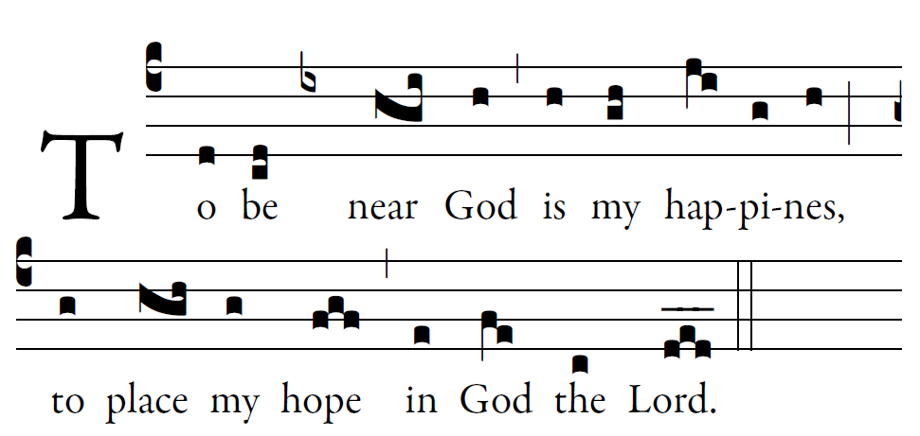

Fr. Columba Kelley ©St. Meinrad Archabbey

Psalm 73 (Psalm 72[73]: 1-2, 21-28: GR, Praenotanda, no. 1)

¹How good is God to Israel,
to those who are pure of heart!
²As for me, I came close to stumbling;
my feet had almost slipped,

²¹And so when my heart grew embittered,
and I was pierced to the depths of my being,
²²I was stupid and did not understand;
I was like a beast in your sight.

²³As for me, I was always in your presence;
you were holding me by my right hand.
²⁴By your counsel you will guide me,
and then you will lead me to glory.

²⁵What else have I in heav-en but you?
Apart from you, I want nothing on earth.
²⁶My body and my heart waste away;
God is the strength of my heart;
God is my por-tion forever.

²⁸To be near God is my happiness;
I have my hope in the LORD God.
I will proclaim your works
at the gates of daughter Sion.

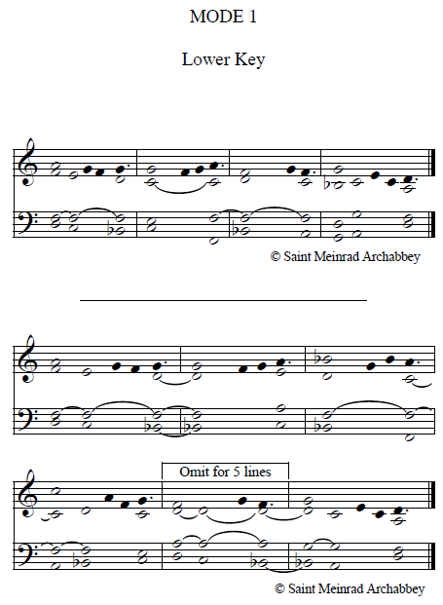

user-notes: Communion 33rd Sunday ;
commentary: Psalm 73 ;
annotation: 1 ;
centering-scheme: english;
%spacing: vichi;
%font: times;
%width: 5;
%height: 11;
%%
(c4)To(hr) be() near() God() is(g) my(f) {hap}piness,(g/ g g.) (:) (z)to(gr) place() my() hope() in() God(e) the(c) LORD.(d.) (::)

