COMMUNION ANTIPHON
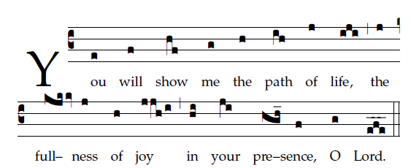
Fr. Columba Kelly ©St. Mainrad Archabbey
PSALM15
LORD, who may abide in your tent
and dwell on your holy mountain?
Whoever walks without fault;
who does what is just,
and speaks the truth from his heart.

Whoever does not slander with his tongue,
who does no wrong to a neighbor,
who casts no slur on a friend,
who looks with scorn on the wicked,
but honors those who fear the LORD.

Who keeps an oath, whatever the cost,
who lends no money at interest,
and accepts no bribes against the innocent.
Such a one shall never be shaken
PSALM 16
Pleasant places are marked out for me:
a pleasing heritage indeed is mine!
I will bless the LORD who gives me counsel,
who even at night directs my heart.

RECESSIONAL HYMN

“Church of God, Elect and Glorious” Verse 2

31st SUNDAY IN ORDINARY TIME
YEAR C

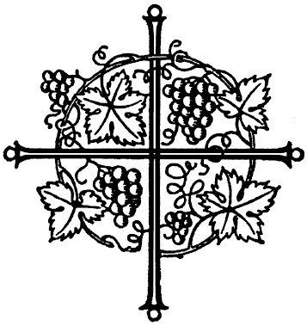

“Today salvation has come to this house…For the Son of Man has come to seek and save what was lost” Luke 19:10

ENTRANCE ANTIPHON

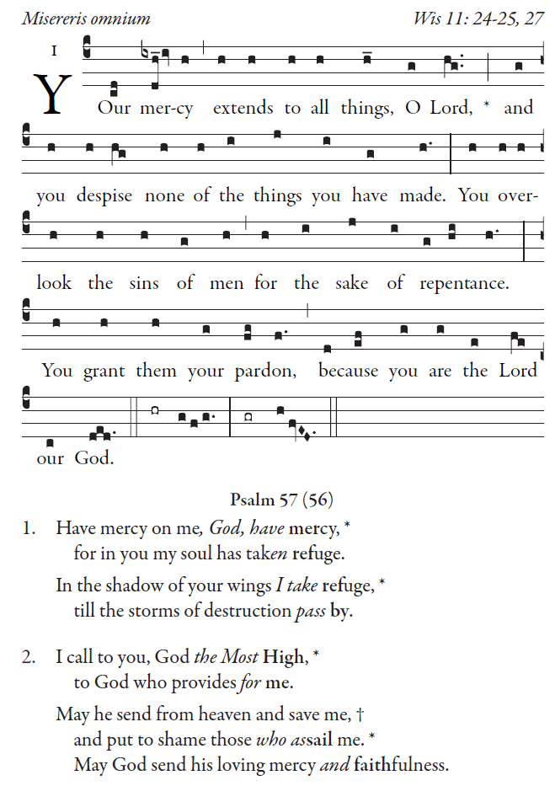
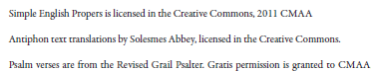

OFFERTORY HYMN

