COMMUNION ANTIPHON:
© ILLUMINAREPUBLICATION.COM
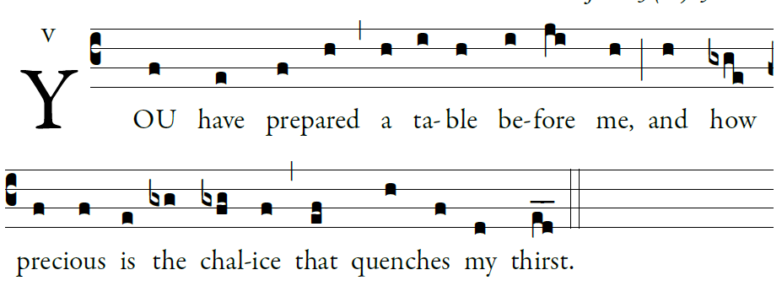

The LORD is my shepherd;
there is nothing I shall want.
²Fresh and green are the pastures
where he gives me repose.
Near restful waters he leads me;
³he revives my soul.
He guides me along the right path,
for the sake of his name.
Though I should walk in the valley of the shadow of death,
no evil would I fear, for you are with me.
Your crook and your staff will give me comfort.
You have prepared a table before me
in the sight of my foes.
My head you have anointed with oil
my cup is overflowing.

COMMUNION HYMN
“Love Divine all Love’s Excelling”

RECESSIONAL HYMN:
“Joyful, Joyful We Adore You”

SECOND SUNDAY
in ORDINARY TIME

ENTRANCE ANTIPHON:
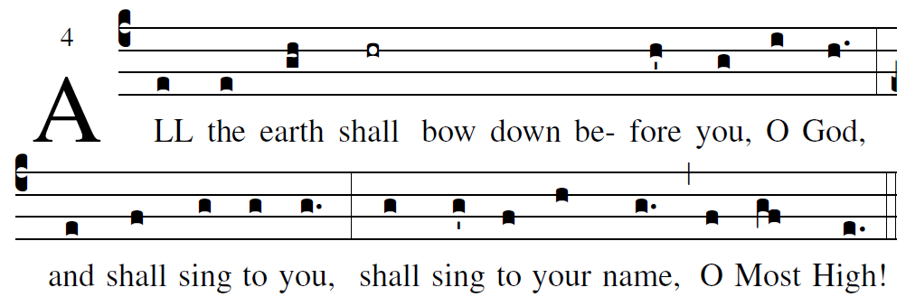
based on the Simple English propers adapted to the Missal 3rd ed.

Cry out with joy to God, all the earth;
O sing to the glory of his name.
O render him glorious praise.
Say to God, “How awesome your deeds!
Because of the greatness of your strength,
your enemies fawn upon you.
Before you all the earth shall bow down,
shall sing to you, sing to your name!”

Come and see the works of God:
awesome his deeds among the children of men.
He turned the sea into dry land;
they passed through the river on foot.

RESPONSORIAL PSALM

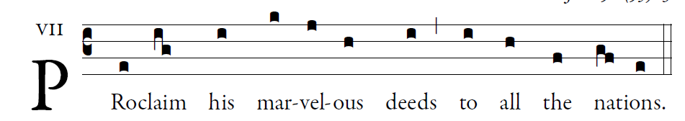

Sing to the LORD a new song;
sing to the LORD, all you lands.
Sing to the LORD; bless his name. 

Announce his salvation, day after day.
Tell his glory among the nations;
among all peoples, his wondrous deeds.  
Give to the LORD, you families of nations,
give to the LORD glory and praise;
give to the LORD the glory due his name! 

Worship the LORD in holy attire.
Tremble before him, all the earth;
Say among the nations: The LORD is king.
He governs the peoples with equity.  

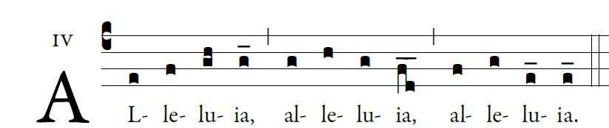

  God has called us through the Gospel to
possess the glory of our Lord Jesus Christ

OFFERTORY HYMN







