ENTRANCE ANTIPHON:

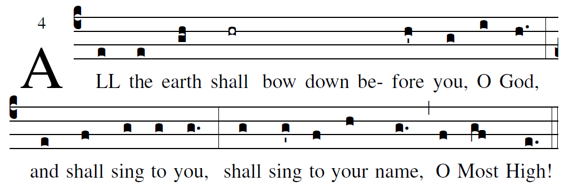
based on the Simple English propers adapted to the Missal 3rd ed.

Cry out with joy to God, all the earth;
O sing to the glory of his name.
O render him glorious praise.
Say to God, “How awesome your deeds!
Because of the greatness of your strength,
your enemies fawn upon you.
Before you all the earth shall bow down,
shall sing to you, sing to your name!”

Come and see the works of God:
awesome his deeds among the children of men.
He turned the sea into dry land;
they passed through the river on foot.

