COMMUNION ANTIPHON
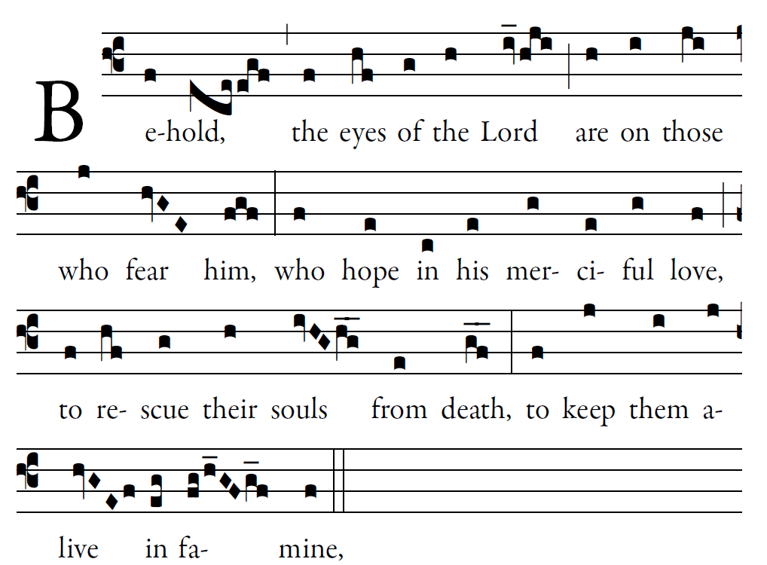
Fr. Columba Kelly ©St. Mainrad Archabbey

Blessed is he whose transgression is forgiven,
whose sin is remitted.
Blessed the man to whom the LORD imputes no guilt,
in whose spirit is no guile.

So let each faithful one pray to you
in the time of need.
The floods of water may reach high,
but such a one they shall not reach.

You are a hiding place for me; [5]
you keep me safe from distress;
you surround me with cries of deliverance.
I will instruct you and teach you the way you should go; I will fix my eyes up-on you.

RECESSIONAL HYMN
“ We are the Light of the World”

29th SUNDAY IN ORDINARY TIME
YEAR A

ENTRANCE HYMN “ Holy, Holy, Holy”
Today’s Missal

Lord Have Mercy, Glory to god, Holy, Lamb of god
Mass of St. Paul the Apostle

RESPONSORIAL PSALM
RB2017
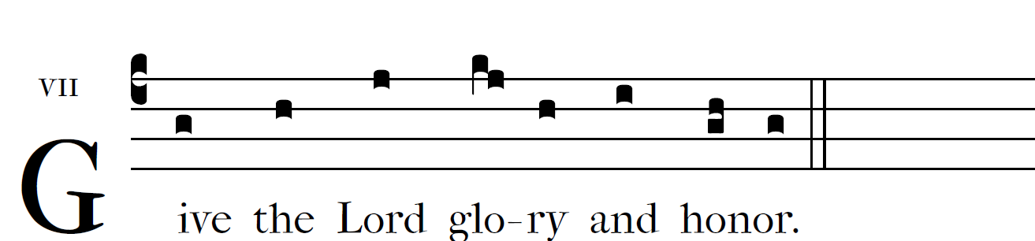

Sing to the LORD a new song;
sing to the LORD, all you lands.
Tell his glory among the nations;
among all peoples, his wondrous deeds.

For great is the LORD and highly to be praised;
awesome is he, beyond all gods.
For all the gods of the nations are things of nought,
but the LORD made the heavens.
 
Give to the LORD, you families of nations,
give to the LORD glory and praise;
give to the LORD the glory due his name!
Bring gifts, and enter his courts.

Worship the LORD, in holy attire;
tremble before him, all the earth;
say among the nations: The LORD is king,
he governs the peoples with equity.
 

ALLELUIA

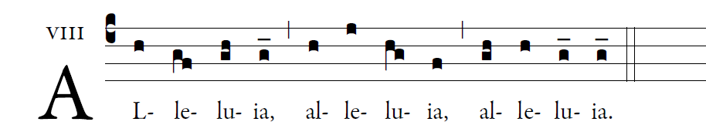

 Shine like lights in the world
As you hold on to the word of life.

OFFERTORY CHANT

͡©illminarepublications.com

Blessed are those whose way is blameless,
who walk in the law of the LORD!
Blessed are those who keep his decrees!
With all their hearts they seek him.

OFFERTORY HYMN: “AVE MARIA” Music Issue

