ALLELUIA
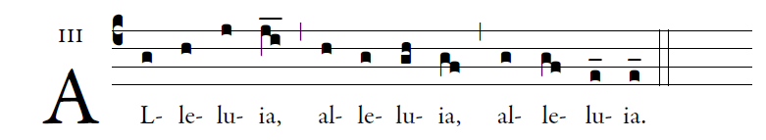
In all circumstances give thanks,
For this is the will of you in Christ Jesus.

OFFERTORY HYMN “ Ave Maria” Music Issue

COMMUNION ANTIPHON

Fr. C Kelly @St. Mainrad Archabbey
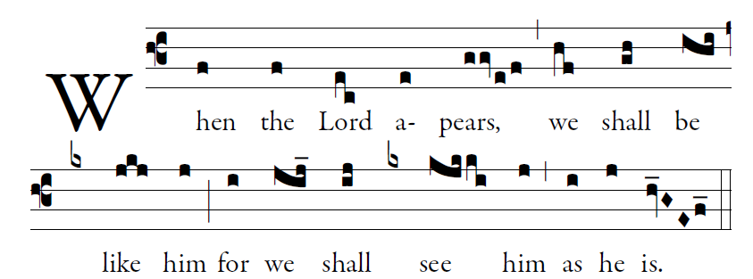
PSALM 63

O God, you are my God; at dawn I seek you;
for you my soul is thirsting.
For you my flesh is pining,
like a dry, weary land without water.
³I have come before you in the sanctuary,
to behold your strength and your glory.

⁴Your loving mercy is better than life;
my lips will speak your praise.
⁵I will bless you all my life;
in your name I will lift up my hands.
⁶My soul shall be filled as with a banquet;
with joyful lips, my mouth shall praise

28th SUNDAY IN ORDINARY TIME (YEAR C)

Adam Bartlett © illluminarepublications.com

Psalm 130
Out of the depths I cry to you, O LORD;
²LORD, hear my voice!
O let your ears be attentive
to the sound of my pleadings.

⁵I long for you, O LORD,
my soul longs for his word.
⁶My soul hopes in the LORD
more than watchmen for daybreak.

Glory be to the Father…

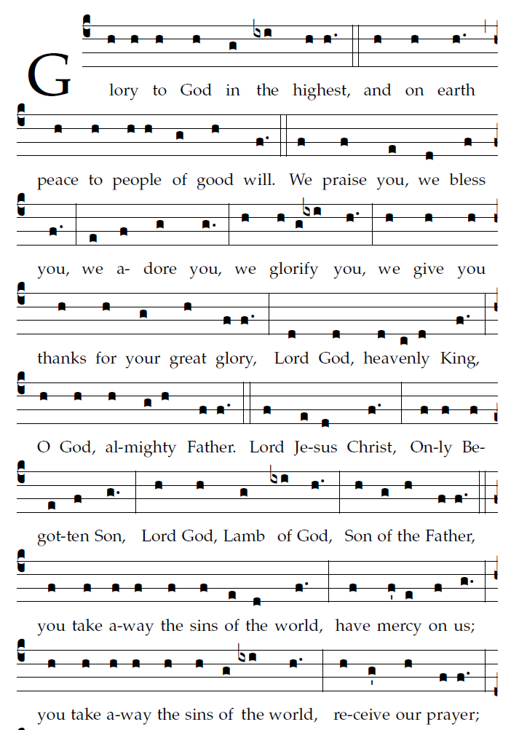

R. Bednarz 2016

REPSONSORIAL PSALM

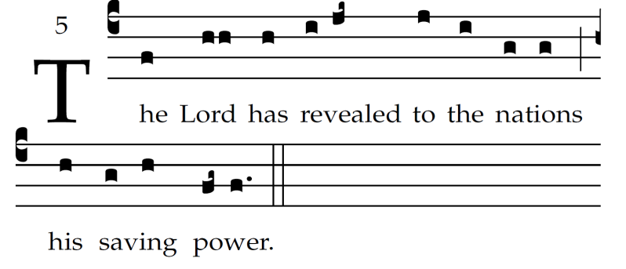

Sing to the LORD a new song,
for he has done wondrous deeds;
His right hand has won victor-y for him,
his holy arm.

The LORD has made his salvation known:
in the sight of the nations he has revealed his justice.
He has remembered his kindness and his faithfulness
toward the house of Israel.

All the ends of the earth have seen
the salvation by our God.
Sing joyfully to the LORD, all you lands;
break into song; sing praise.

