I will bless you all my life;
in your name I will lift up my hands.
My soul shall be filled as with a banquet;
with joyful lips, my mouth shall praise you.

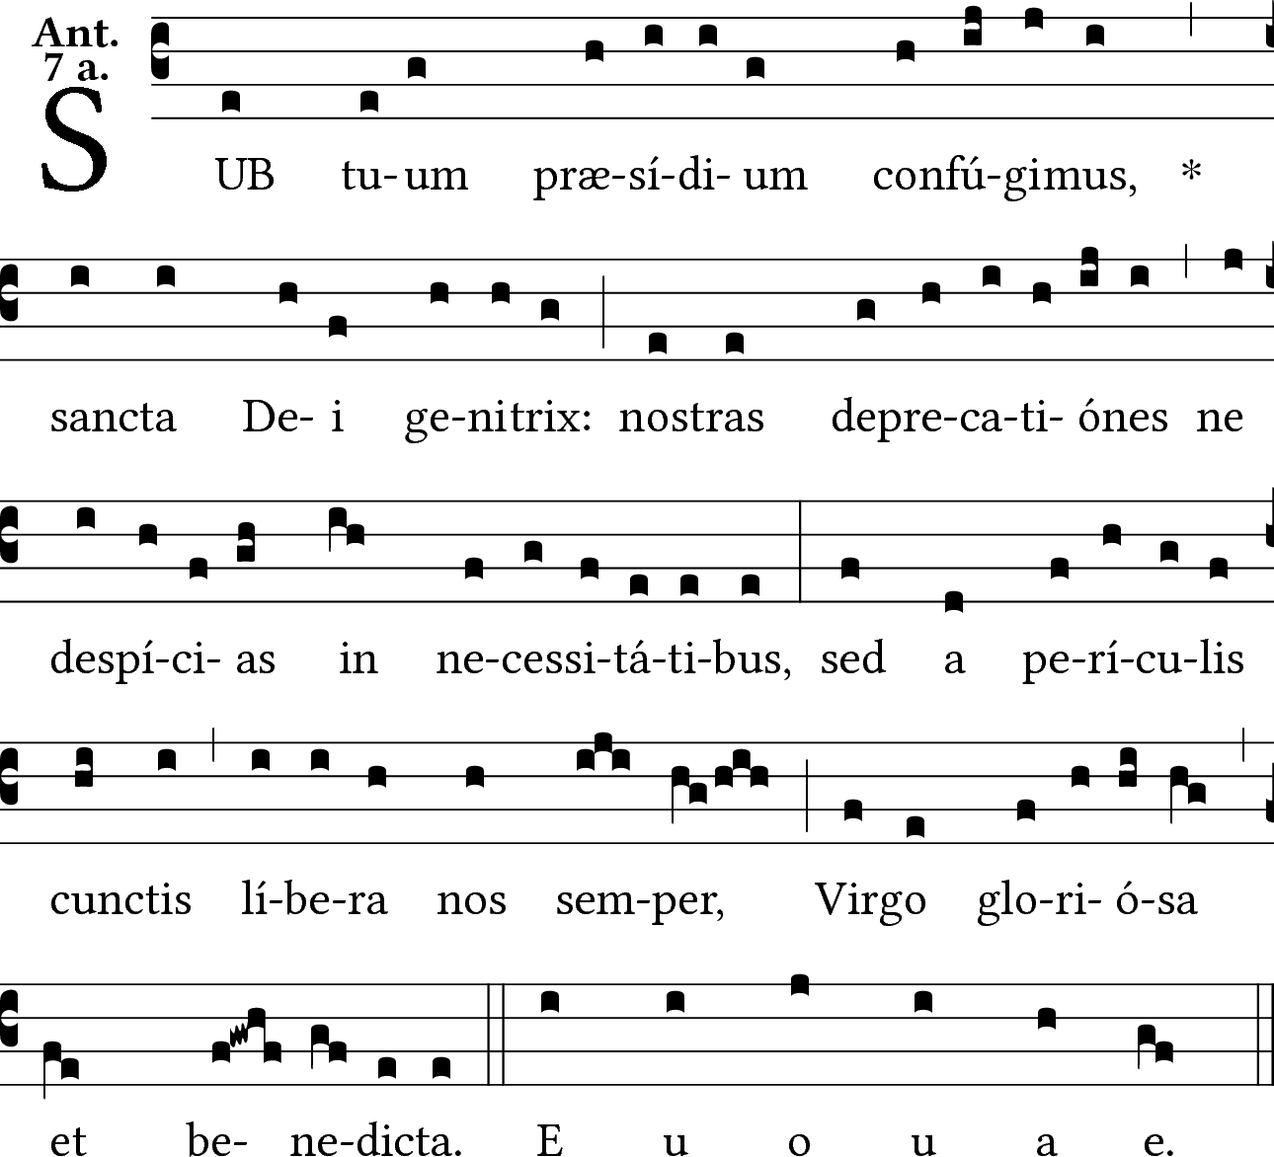

We take refuge under thy protection, holy Mother of God: Do not despise our prayers in time of necessity: but always free us from all dangers,O blessed and glorious Virgin.

RECESSIONAL HYMN:
“To Jesus Christ Our Sovereign King”

28th SUNDAY IN ORDINARY TIME

Adam Bartlett © illluminarepublications.com

Out of the depths I cry to you, O LORD;
²LORD, hear my voice!
O let your ears be attentive
to the sound of my pleadings.

⁵I long for you, O LORD,
my soul longs for his word.
⁶My soul hopes in the LORD
more than watchmen for daybreak.

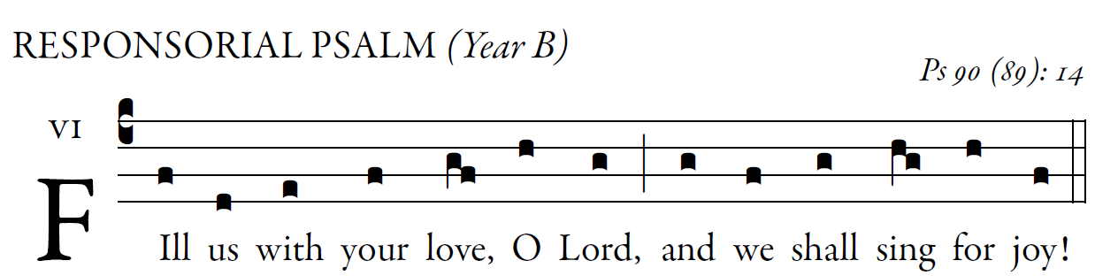

Teach us to number our days aright,
that we may gain wisdom of heart.
Return, O LORD! How long?
Have pity on your servants!

Fill us at daybreak with your kindness,
that we may shout for joy and gladness all our days.
Make us glad, for the days when you afflicted us,
for the years when we saw evil.

Let your work be seen by your servants
and your glory by their children;
and may the gracious care of the LORD our God be ours;
prosper the work of our hands for us!
Prosper the work of our hands!

ALLELUIA
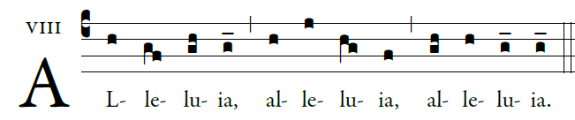

OFFERTORY HYMN “ Ave Maria” Music Issue

COMMUNION ANTIPHON
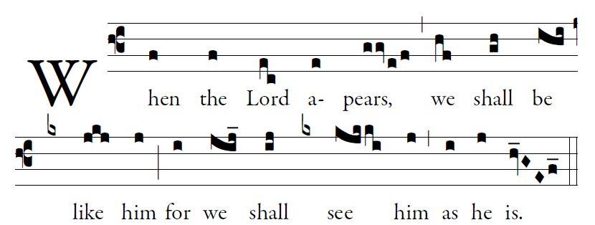

Fr. C Kelly @St. Mainrad Archabbey
PSALM 63
O God, you are my God; at dawn I seek you;
for you my soul is thirsting.
For you my flesh is pining,
like a dry, weary land without water.
³I have come before you in the sanctuary,
to behold your strength and your glory.

