COMMUNION ANTIPHON

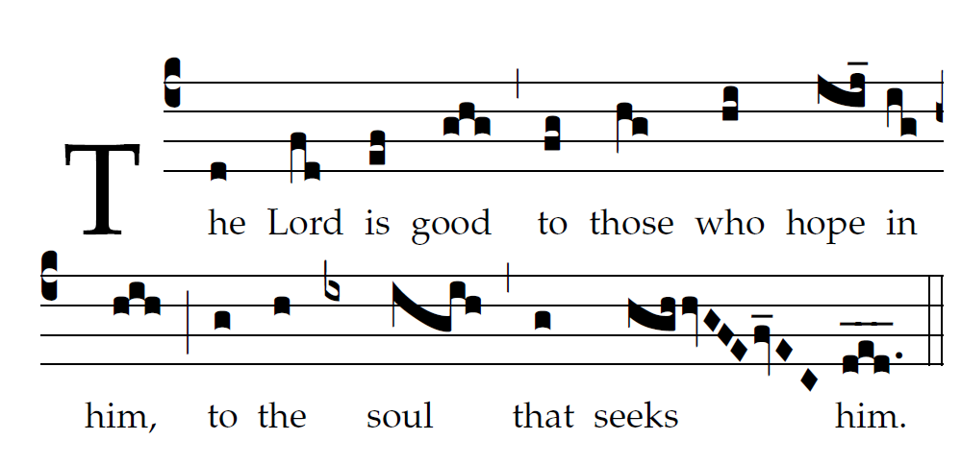
Fr. C Kelly @St. Meinrad Archabbey
Psalm 103

Bless the LORD, O my soul,
and all within me, his holy name.
²Bless the LORD, O my soul,
and never forget all his benefits.

³It is the LORD who forgives all your sins,
who heals every one of your ills,
⁴who redeems your life from the grave,
who crowns you with mercy and compassion,
⁵who fills your life with good things,
renewing your youth like an eagle’s.

⁶The LORD does just deeds,
gives full justice to all who are oppressed.
⁷He made known his ways to Moses,
and his deeds to the children of Israel.
⁸The LORD is compassionate and gracious,
slow to anger and rich in mercy.

RECESSIONAL HYMN

“Immaculate Mary

27th SUNDAY IN ORDINARY TIME (YEAR C)

ENTRANCE 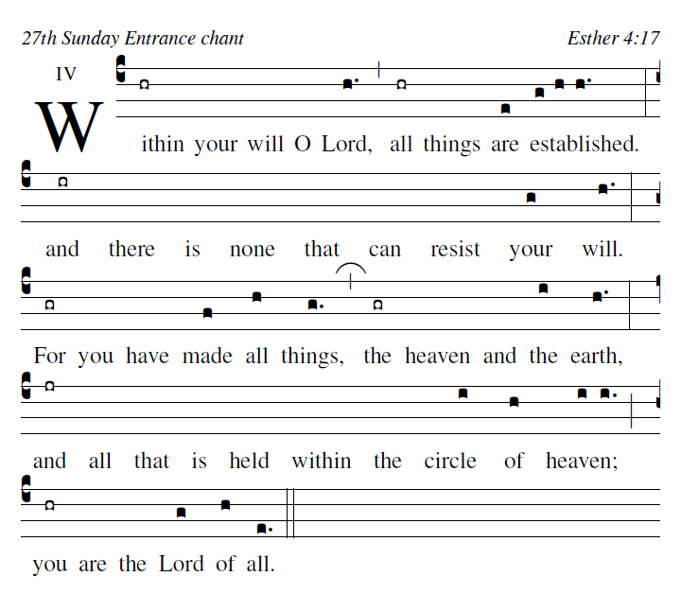

Blessed are those whose way is blameless,
who walk in the law of the LORD!
Blessed are those who keep his decrees!
With all their hearts they seek him.

They never do anything evil,
but walk in his ways.
You have laid down your precepts
to be care-fully kept.

May my ways be firm
in keeping your statutes.
Then I shall not be put to shame
as I observe all your commands.

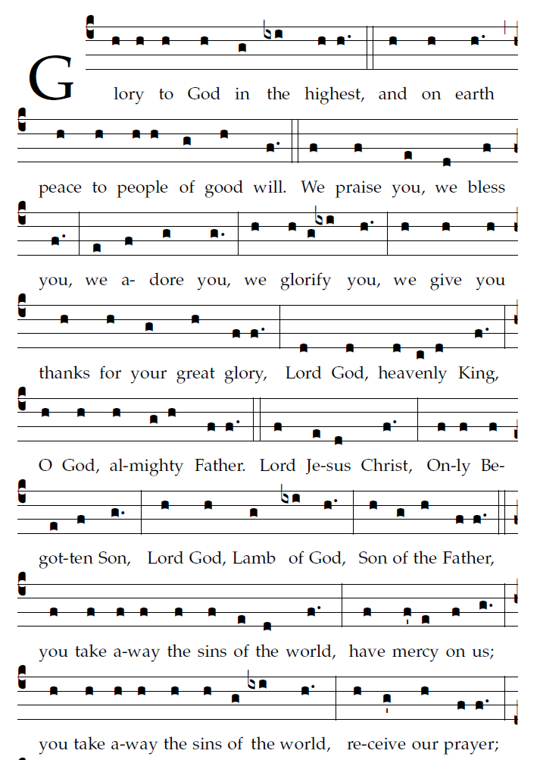

RESPONSORIAL PSALM
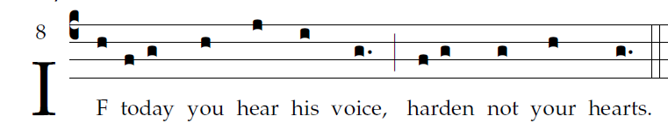

Come, let us sing joyfully to the LORD;
let us acclaim the Rock of our salvation.
Let us come into his presence with thanksgiving;
let us joyfully sing psalms to him.
Come, let us bow down in worship;
let us kneel before the LORD who made us.
For he is our God,
and we are the people he shepherds, the flock he guides.
Oh, that today you would hear his voice:
“Harden not your hearts as at Meribah,
as in the day of Massah in the desert,
Where your fathers tempted me;
they tested me though they had seen my works.”

