COMMUNION ANTIPHON

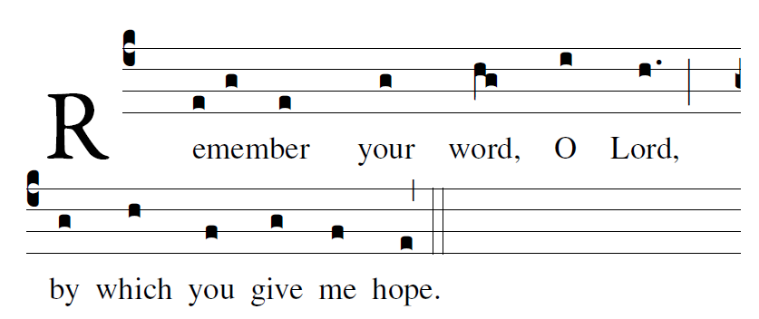

Blessed are those whose way is blameless,
who walk in the law of the LORD!
²Blessed are those who keep his decrees!
With all their hearts they seek him.

My soul holds fast to the dust;
revive me by your word.
²My soul pines away with grief;
by your word raise me up.

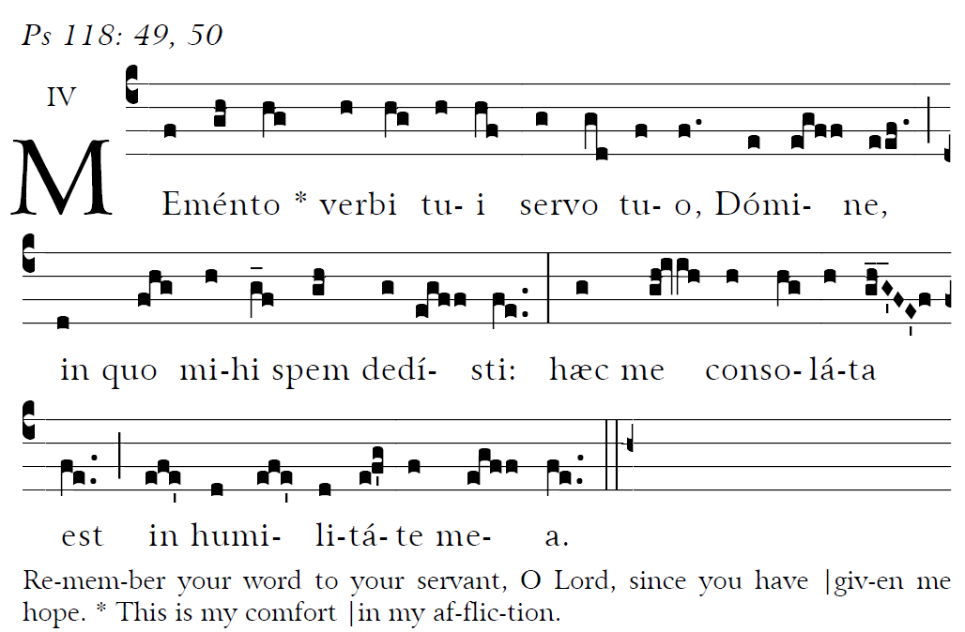

RECESSIONAL HYMN
“Come ye Thankful People Come”

26th Sunday in Ordinary Time YEAR a

ENTRANCE HYMN
“At the Name of Jesus” Music Issue Hymnal

Mass XI “ ORBIS FACTOR”

Lord have mercy, Glory to God, Holy, Lamb of God.
are found in a separate program

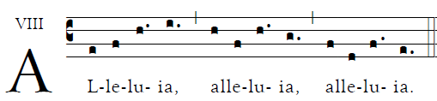

                    Though our Lord Jesus Christ was rich, he became poor, so that by his poverty you might become rich.. 

Offertory antiphon © 2012-2014 Adam Bartlett, licensed under a Creative Commons Licens www. Illuminarepublications.com Communion antiphon 1.Fr. C Kelly St Meinrad Archabbey. Memento verbi from the Gradual Romanum

OFFERTORY ANTIPHON

On the poplars that grew there
we hung up our harps.
³For it was there that they asked us,
our captors, for songs,
our oppressors, for joy.
“Sing to us,” they said,
“one of Sion’s songs.”

AVE MARIS STELLA (choir)
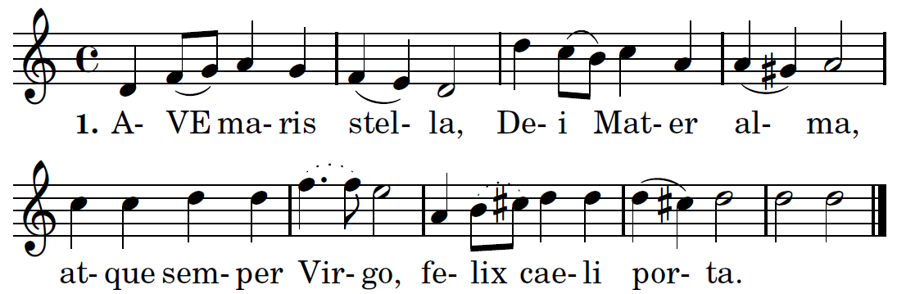

Translation 1. Hail, bright star of ocean,
God's own Mother blest,
Ever sinless Virgin,
Gate of heavenly rest.

2. Taking that sweet Ave
Which from Gabriel came,
Peace confirm within us,
Changing Eva's name.

3. Break the captives' fetters,
Light on blindness pour,
All our ills expelling,
Every bliss implore.

4. Show thyself a Mother;
May the Word Divine,
Born for us thy Infant,
Hear our prayers through thine.

5. Virgin all excelling,
Mildest of the mild,
Freed from guilt, preserve us,
Pure and undefiled.

6. Keep our life all spotless,
Make our way secure,
Till we find in Jesus,
Joy forevermore.

7. Through the highest heaven
To the Almighty Three,
Father, Son and Spirit,
One same glory be. Amen.

